

Fay’s Computer Science Notes

Year 10

Binary, Hexadecimal and All That

Binary

Binary is the only number system that computers can process raw, as computers are made up of transistors which only allows it to process 2 values. It is made up of only 0s and 1s, representing ‘on’ and ‘off’, so it is called a base-2 system. A binary number is represented in bits of 0s and 1, essentially, places.

One bit has two possibilities; 0 or 1. So, if there are 2 bits, there are:

00 (Possibility 1)

01 (Possibility 2)

10 (Possibility 3)

11 (Possibility 4)

4 possibilities. By understanding this logic, the range of a binary register[1] is equal to 2 to the power of the number of bits.

So, 3 bits would have 8 possibilities, 4 bits would have 16 possibilities, and so on. IGCSE questions will usually ask you to calculate values for 8-bit binary numbers.

‘10’ in binary does not mean ten in denary, our regular, usual, human number system. The binary system is based off place headings. Similarly to how the denary system uses tens, hundreds and thousands, the place of the bit affects the significance and value of what that bit holds.

Remember, in these kinds of numbering systems, it always starts from the right with the power of 0.

_2^7 _2^6 _2^5 _2^4 _2^3  _2^2 _2^1  _2^0

The best way to think about it is that whatever is in the bit, multiply it by its heading, as hexadecimals also work this way. So, if it looks like this:

12^7 02^6 02^5 02^4 12^3  12^2 02^1  12^0

Then, the value of each place will be:

(1*128)2^7 (0*anything is 0)2^6 02^5 02^4 (1*8)2^3  (1*4)2^2 02^1  (1*1)2^0

And thus, the values of each of the non-zero places will be 128, 8, 4 and 1.

Like denary, these values are added up to create the full number value; which, in this case, is 143.

Although there is a range of 256 (2^8) values in an 8-bit number, the possible values are 0-255, because that range also includes the value 0. With this, the maximum value can be determined by the range subtracted by 1.

Hexadecimals

Hexadecimals were invented to make it easier for humans to look at computer values rather than looking at the eyesore binary is.

It uses the same concept as binary, except that one place in hexadecimal can hold a range of 16 values, from 0-15. To do this, it uses the digits 0 to 9 and the characters A to F for values 10 to 15[2]. Because of this, it is a base-16 system.

It must be kept in mind that one place in binary is *not* equivalent to a byte. Binary has two possible values, while hex has sixteen. 16 = 2^4, so one hex place is one byte.

A16^2 016^1  316^0

Would be equivalent to:

1016^2 016^1  316^0

Which, after multiplying, would be:

2560, 0, and 3.

Adding them up gives us a value of 2563.

Fortunately, oftentimes, the biggest hex value one would have to calculate would only have 2 places.

Hex is usually written with a hashtag (#) as an indicator, so the previous hex value would be written as *#A03*.[3]

Denary

There is not much to explain, but I’m just saying here that denary uses digits 0-9 to represent values. The range is 10, so it’s a base-10 system.

If you wanna think about it in a similar way to binary and hex, every place from the right increases in powers of 10.

Converting to Hell and Back

I already taught you how to convert both number systems to denary, but that’s not the end of it.

Denary to binary

You could try to achieve this by trial and error, but the test would be over by the time you solve it. There is a definite way to do this.

This is the working for converting 57 into binary:

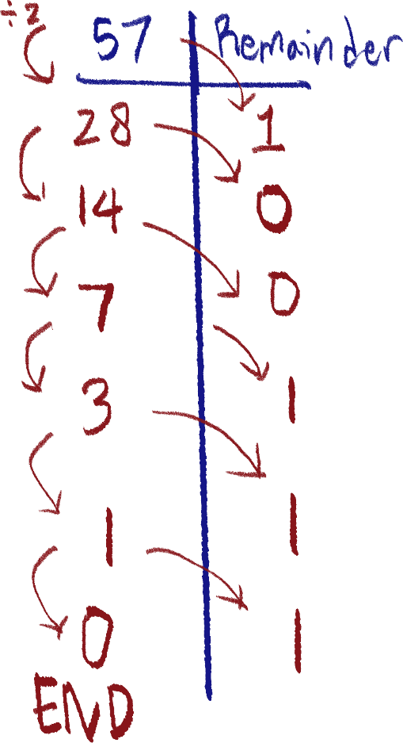

The steps are:

1. Divide current number by 2 and write result without remainder/decimals for next number.
2. If there is a remainder (odd numbers always have remainders, even numbers don’t), write 1 on the remainder side.
3. If there isn’t a remainder, write 0.
4. If the number is 1, write 1 on remainder side and the end result is 0[4].
5. Continue steps until you reach 0.

Once you reach 0, write the remainder digits from *bottom to top,* and that is the binary number. So, 57 in binary would be 111001.

Hex to binary and back to hex

1 place in hex (16 possibilities) is equivalent to 4 places in binary (2^4 = 16 possibilities), so, if we have #A03 again, it would translate to each place, 10, 0 and 3.

10 in 4-bit binary is 1010.

0 is 0000.

And 3 is 0011.

So, #A03 is 1010 0000 0011 in binary.

In the same way, binary can be translated into hex. On should split the bits into groups of 4, *starting from the left*. Here is the binary number we’ll be working with:

11100101010

After splitting:

111 0010 1010

When the last bits are less than a group of 4, add zeroes until they do so.

And remember, each 4 bits starts a new line of headings.

01112^0 00102^0 10102^0

Converting them, we get 7, 2 and 10. Which in hex, will be #72A. As a note, #72A and 011100101010 (as pure binary) converted to denary will have the same result.

NOTE THAT THIS TOTALLY DOESN’T WORK WITH DENARY, THE SECTIONING UP THING. Did it myself got everything wrong because of that.

Denary to hex

There are two methods that you can select according to which is most comfortable. The first is by converting the denary to binary and then to hex.

The second method is directly converting from denary to hex, in a similar technique to converting *denary to binary*.

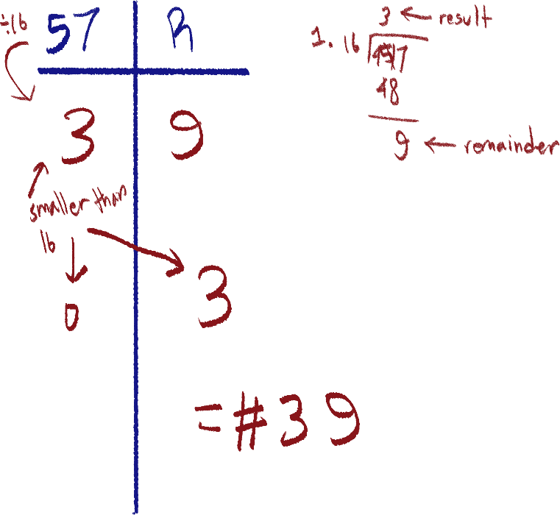You divide by 16 instead of 2, like in the binary version of this method, until you reach 0.

But, the remainder while dividing should be kept and written. If the number is smaller than 16, write that number as the remainder and have the result as 0.

So, in this case, 57 is #39 in hex.

Logical binary shifting

Shifting binary numbers one place to the left will multiply the value by 2, while shifting to the right halves it. Think of shifting like the values moving down a conveyor belt.

01010 = 10

10100 = 20 (left shift by 1)

00101 = 5 (right shift by 1)

This can continue to multiply a binary number by 4 (2^2), for example, but if it passes the bit number:

01000 = 8 (left shift by 2)

This will end in a completely incorrect result, as:

1. Data has been lost/removed due to shift going past register bit size, resulting in an incorrect final value.
2. The original value (10) multiplied by 4 (=40) is above the maximum value able to be represented with the number of bits on this register (max. is 2^5 – 1 = 31).

You can imagine it like leaving something on a conveyor belt and losing it as it rolls under.

Adding binary values

It follows a similar flow to denary long addition, but there are rules to follow:

1. If you are adding 0 and 0, the result is 0.
2. If you are adding 1 and 1 the result is 0 with a carry of 1 to the next place.
3. If you are adding 1 and 1, and you also have a carry of 1 in that place, the result is 1 with a carry of 1 to the next place.
4. A 1 cannot be carried past the number of bits.

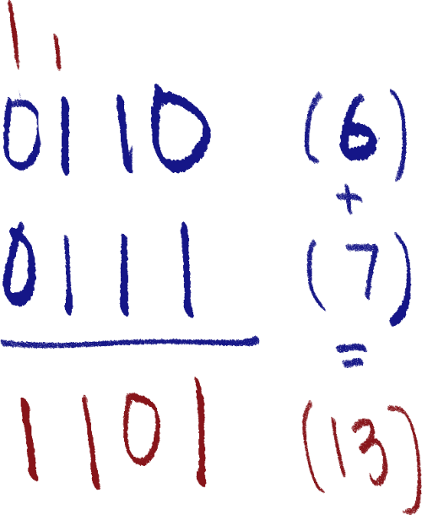Here is an example with 0110 and 1101, resulting in 1101.

But, if the sum of the addition is larger than the maximum value of the bit amount, although it is possible for us to simply write in an extra bit on the left, computers usually have registers with a fixed number of bits, so the value will be incorrect. This is called an overflow error.

Here is an example of an overflow error:

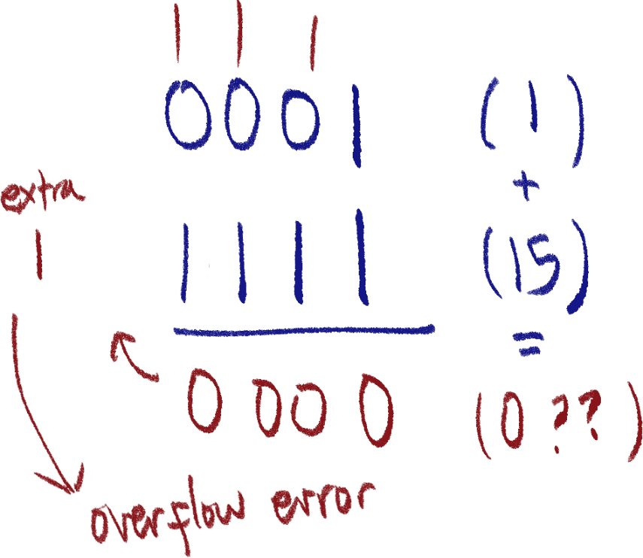

All The Stuff You Can Do

Text to binary

Computers process text using character sets, such as ASCII and Unicode. Character sets are used to hold every character and symbol that can be represented by a computer system. Character sets assign each character a unique value. For example, 65 is A in ASCII.

Unicode works the same way but has much more bits as it has a much wider range of characters than ASCII, including other languages and emojis.

Standard ASCII uses 7 bits (127 characters), Extended ASCII uses 8 bits (255 characters), and Unicode uses a whopping 16 bits (approx. 65000 characters).

Hex uses

1. To define locations in memory

I’m not too sure, but I believe these are called *memory addresses,* which point to the location of machine code or data.

1. MAC addresses

Media Access Control addresses are made up of 12-digit hex numbers and is a unique code assigned to a device when it first connects to a network, and cannot be changed.

1. IP addresses

An IP address is a unique address made up of 8 hexadecimal digits, and is used to identify devices connected to the internet, in order for them to communicate with each other.

1. Hex color codes

Computers process and present color by using 3 pairs of hex digits, a pair for each color channel, red, green and blue, so each channel has a range of 256, with an accumulative range of 2^24 different colors.

1. Displaying error messages

Error codes displayed by the computer in hex can be read by a programmer to figure out what error is associated with the code.

Reasons we use represent values in hex instead of binary

You can represent any binary in value with hex, and vice versa. The reason we use hex is not because computers can process it, because computers only work with on and off, but because it’s easier to read, and it takes up less space on displays. For example, it would be a much bigger pain to read a 128 bit IPv6 address when you can represent it as 32 hex values instead.

|  |  |
| --- | --- |
| Unit | Equivalent |
| b (Bit) | 1 place in binary |
| B (Byte) | 8 bits |
| Nibble | 4 bits / 1 hex place |
| KB (Kilobyte) | 1000 B / 1024 B |
| KiB (Kibibyte) | 1024 B |
| MB (Megabyte) | 1000 KB / 1024 KB |
| MiB (Mibibyte) | 1024 KB |

|  |  |
| --- | --- |
| Unit | Equivalent |
| GB (Gigabyte) | 1000 MB / 1024 MB |
| TB | 1000 GB / 1024 GB |
| Hz (Hertz) | (unit for frequency) |
| KHz (Kilohertz) | 1000 Hz |
|  |  |
|  |  |
|  |  |

Extra mnemonic for storage

Kissed

My

Girlfriend

To

Propose

Engagement

Kibibyte (1024 B)

Mebibyte (1024 KiB)

Gibibyte (1024 MiB)

Tebibyte (1024 GiB)

Pebibyte (1024 TiB)

Exbibyte (1024 PiB)

(Couldn’t think of anything else)

Almost forgot two’s complement

Two’s complement is a way to represent negative numbers in binary. It is a format where the last bit (leftmost bit) is made to be negative. For example, in 01, the bit with 0 represents –(21) rather than 21 as usual. Also, note that two’s complement is totally different from signed magnitude. That one’s a lot easier.

This means that the range goes from the minimum negative value (the last bit negative) until the 2positive bits-1.

Converting from denary to 2’s complement binary

Let’s say we want to convert -54 into binary, in 2’s complement (8-bit). First, we convert 54 (positive) into binary.

54 -> 00110110

Next, we flip all the bits – turn 0s into 1s and 1s into 0s.

00110110 -> 11001001

Finally, we add 1 to the value.

11001001 + 1 = 11001010

If you count it up manually:

-128 + 64 + 8 + 2 = -54

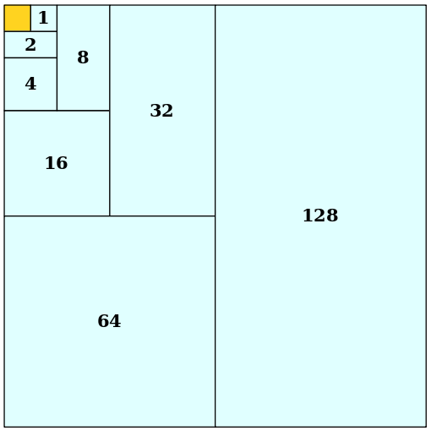Nice reference I found

It’s just an easier way to visualize why the range of a bit register is equal to 2bits– 1.

More explanation to make my brain accept this is that this rule applies only when 20 is included.

20+21+22 = 23-1, check it out.

Audio and Images

Sound representation

There are 3 parts to a digital sound file; the sample resolution, sample rate, and time. Time is of course how long the sound goes, but I’ll have to explain the other two.

Sound, in real life, is a series of waves caused by material vibration in the air. However, computers cannot record and process every wave in the air, not to mention every point of those waves. So, a computer uses samples, taking only one point of the soundwave and records the amplitude of it. It repeats this sampling over and over, in small intervals to mimic the vibration of sound. In short, a sample is a measurement of a sound’s amplitude at a specific point of time.

Sample resolution is the variety of amplitudes the sound file can have. Amplitude determines how loud the sound is. The different amplitudes are represented here in bits; with one value representing one level of amplitude.

This means that a higher sample resolution will result in higher quality sound, because the higher number of different values of amplitude allow for the representation of more accurate amplitudes. Old video games, such as the ones on the Game Boy, are in 8-bit resolution.

Sample rate is how many samples there are in one second, measured in Hz (Hertz). With a higher sample rate, imagine more points on the graph – the line will be smoother.

Thus, a higher sample rate will also give higher sound quality.

An analog-to-digital-converter (ADC) is a device used to convert analog signals into digital signals, and is needed for this to turn sounds into bit information.

The following image is a graph depicting how a hypothetical, really bad 3-bit, 2 Hz microphone would process a real sound (in red).

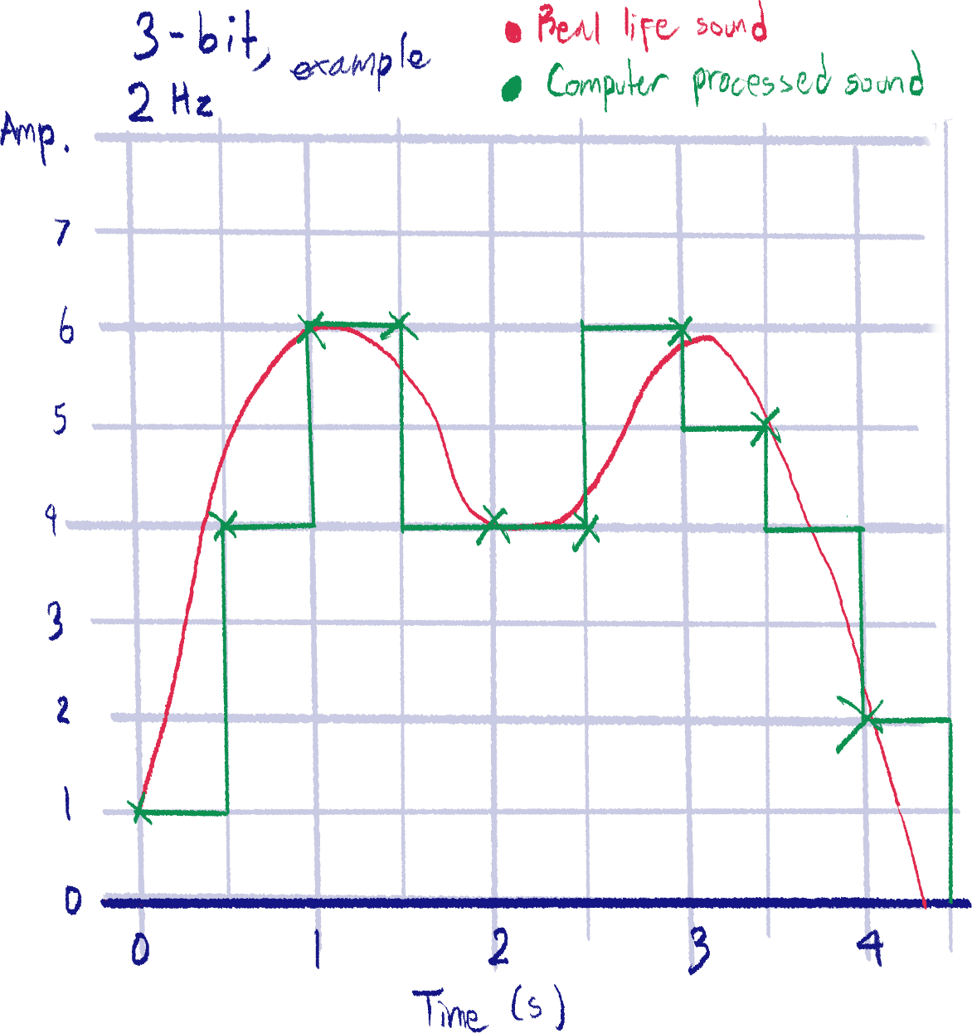

As you can see, the computer cannot re-graph the line to perfectly match the original sound. The line it has ended up with is so bad and off because of the low resolution and sample rate. Because it cannot go between amp. values, (like they cannot have 5.7) it is incredibly inaccurate in amplitude. The sample rate is so low that it cannot catch some of the changes in amplitude.

Next, we will measure the size of this sound file. The formula for this is:

Sample res. (b) X Sample rate (Hz) X Time (s) = Size (b)

Keep in mind the units. If you are given the rate in KHz, or the resolution in B, make sure to convert first.

So with this, the awful sound file’s size will be:

3 b X 2 Hz X 4.5 s = 27 b

Digital images

This is an example of a raster image.

All electronic screens display images and color using pixels, a very small block of the screen made up of LEDs that light up a specific color.

There are two types of digital image files; raster and vector files.

Raster files include .png, .jpg/jpeg, .gif, and .tiff files. Raster files save image data as individual pixels with each of their colors. However, this means they can have a larger file size. A characteristic of a raster image is that when zoomed in, the pixels will be visible.

Vector images represent image data in mathematical equations (imagine; curve graph, x and y stuff) forming shapes. Due to this, vector images take up less file space, and can be zoomed in very far.

This is an example of a vector image (although stupid Word to PDF compression will ruin and pixelate the image anyways).

Image resolution is simply the number of pixels that make up the image. If an image is 10 pixels wide and 5 pixels long, I can multiply them to find 50 pixels that make up the entire image.

This also means that the higher the image resolution, the higher quality the image is (a very pixelated image would be low quality, wouldn’t it?)

Also, colors in images are represented by bit values, the range called the bit depth. a certain number of bits for each pixel. Here is an example with 1 bit for each pixel.

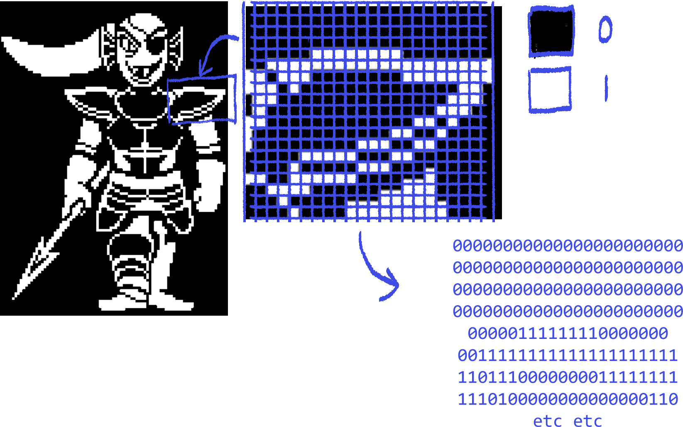

A colored image will obviously have much more colors. The standard for web images is the aforementioned hex codes, 6 hex values, meaning 24 bits, meaning 224 different colors.

Calculating image size

One can calculate an image’s size by using this formula:

Resolution * bit depth

This is because you’re just counting how many bits there are by each pixel. However, when solving such problems, pay attention to the unit of space asked for; here is an example:

An image with the dimensions 1920 by 2560 has a depth of 8 bits. Calculate the size in bytes.

So, since we need bytes, we just need to divide the result of the formula (which would be in bits) by 8, being:

1920px * 2560px * 8 bits / 8 bits

= 4 915 200 bytes

File compression

File compression is used for a variety of reasons:

* Makes file transmission faster
* Uses up less hard drive and cloud storage space
* Uses less internet data from file transmission
* Makes video, audio and image streaming smoother

There are two types of data compression:

1. Lossless compression

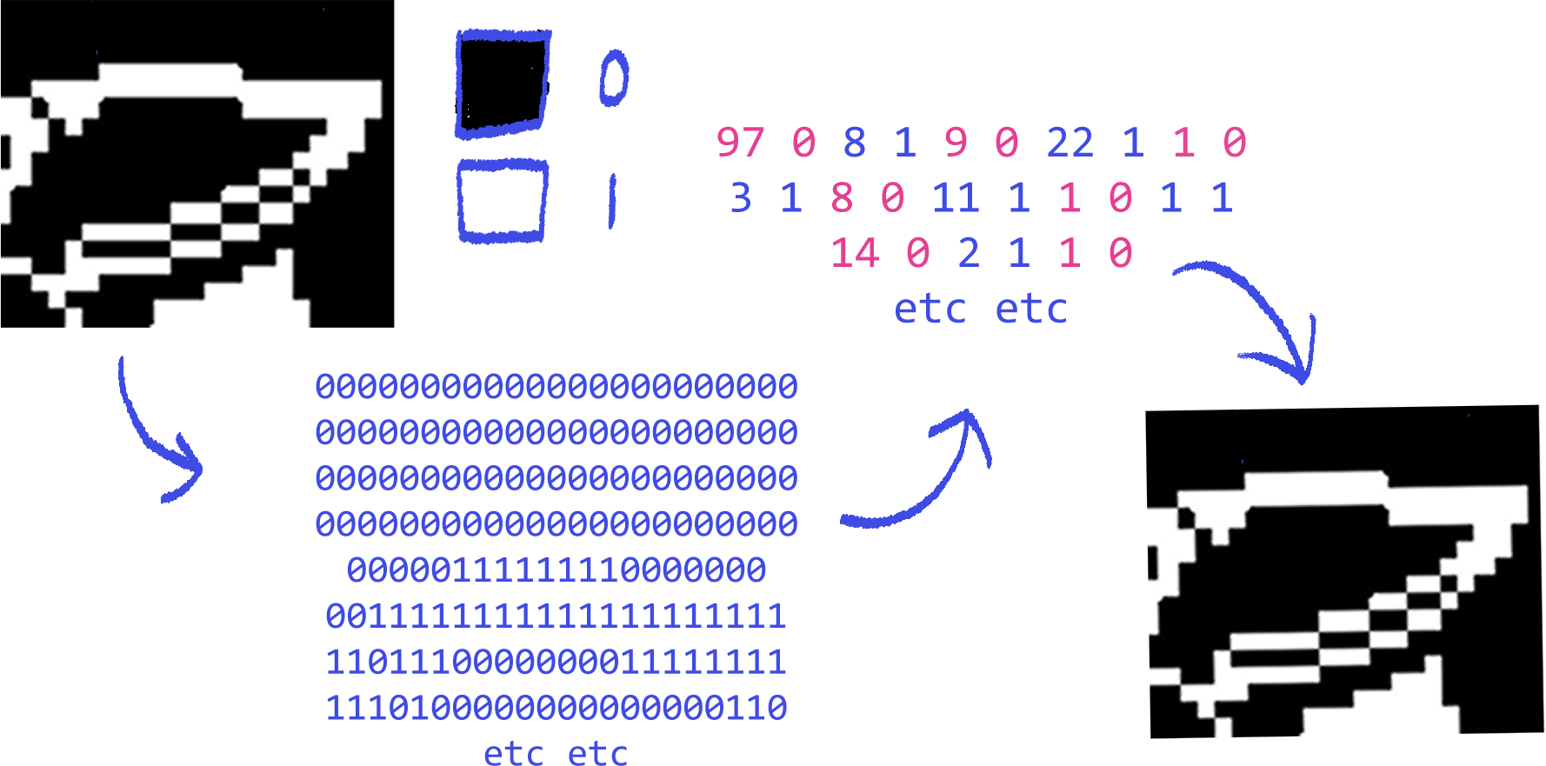 This kind of compression does not remove any of the file’s original data, with no loss of information. One method of lossless compression used for images is called RLE (run-length encoding), where the structure is [number of bits] [bit value]. If we use the Undyne example from the image file example, we can see how it works:

As you can see, no data has been removed, only shortened by removing repeating pixels (repeating is the keyword here) , in a process that can be described as collation or indexing.

Because of these benefits, lossless compression is usually used for files that cannot have any data removed, for example, text files.

It is also generally used if you don’t really need to compress it that much.

Another lossless compression technique used for videos is removing data of repeating frames.

1. Lossy compression

 Lossy compression makes files smaller by removing data from the file. For example, this is an actual drawing I compressed in MS Paint. The image resolution is smaller, thus reducing the file size, but it compromises quality, and the original file cannot be reconstructed. Another way to compress images is by reducing the color depth.

However, lossy compression is often used for images, audio, and videos, because the compression isn’t very noticeable at times, or quality is not relevant in the situation.

For example, audio is almost always lossy because a computer can’t capture a sound wave/analog signal perfectly.

Images on webpages are often lower in quality to have the page load faster, as the quality in most cases isn’t a major point.

A lossy compression technique for audio is perceptual music shaping, where sounds that humans cannot hear are removed from the data.

Data Transmission – Packet Switching

The basics of packet switching

It is very difficult to send data in its entirety at once through the internet. A lot more internet data must be used at once to send it, and if there is an error with the data, the entire thing has to be sent again. Inefficient.

This is why data is split into multiple data packets when being sent through the internet; it is sent part by part, to be reassembled again whole at the destination.

Data packeting also helps with the error problem aforementioned, as only the packet with the error in it needs to be resent.

Here is how data is transmitted through the internet:

1. Sender’s device splits data into multiple packets, sends them to destination device
2. The packets that go through the network are forwarded by routers, which control the internet traffic.
3. When the packets reach the destination, they are put together in order to get the original data. If a packet is never received or has an error, it is resent by the sender.

Packet parts

There are three parts to a packet; the header, payload, and trailer.

The header contains the IP addresses of the sender and destination, as well as the order number of the packet, so they can be reassembled in correct order.

The payload is just the data itself.

The trailer has information marking the end of the packet as well as a checksum, to check if the packet contains any errors.

Wire Transmission

Serial and parallel

Serial data transmission sends data through one wire, bit by bit. The next bit is only sent after the last one has already reached the recipient device.

Parallel data transmission sends multiple bits at once through multiple wires; for example, parallel transmission using 8 wires will send a bit in each wire at once. The next batch of bits are only sent after the previous bits have already reached the recipient device.

These days, serial data transmission is used more often than parallel data transmission, because of multiple factors:

* + 1. Parallel transmission does not guarantee the bits to be sent in the correct order, so they need to be reordered. If not correctly reordered, data will be skewed.
    2. There is the chance of crosstalk occurring, changing the bit values in parallel transmission. Crosstalk occurs due to electromagnetic interference[5] between cables.[6]
    3. More wires, more money.
    4. Parallel wires are only suitable for transmitting within distances less than 5 meters.

USB (Universal Serial Bus) and SATA (Serial Advanced Technology Attachment) are examples of often-used serial cables.

But, parallel transmission is still used inside hardware, between components like the CPU and RAM, where data needs to be sent very quickly. Because of the short distance, errors are unlikely, and the wires are separated and isolated properly as to prevent crosstalk.

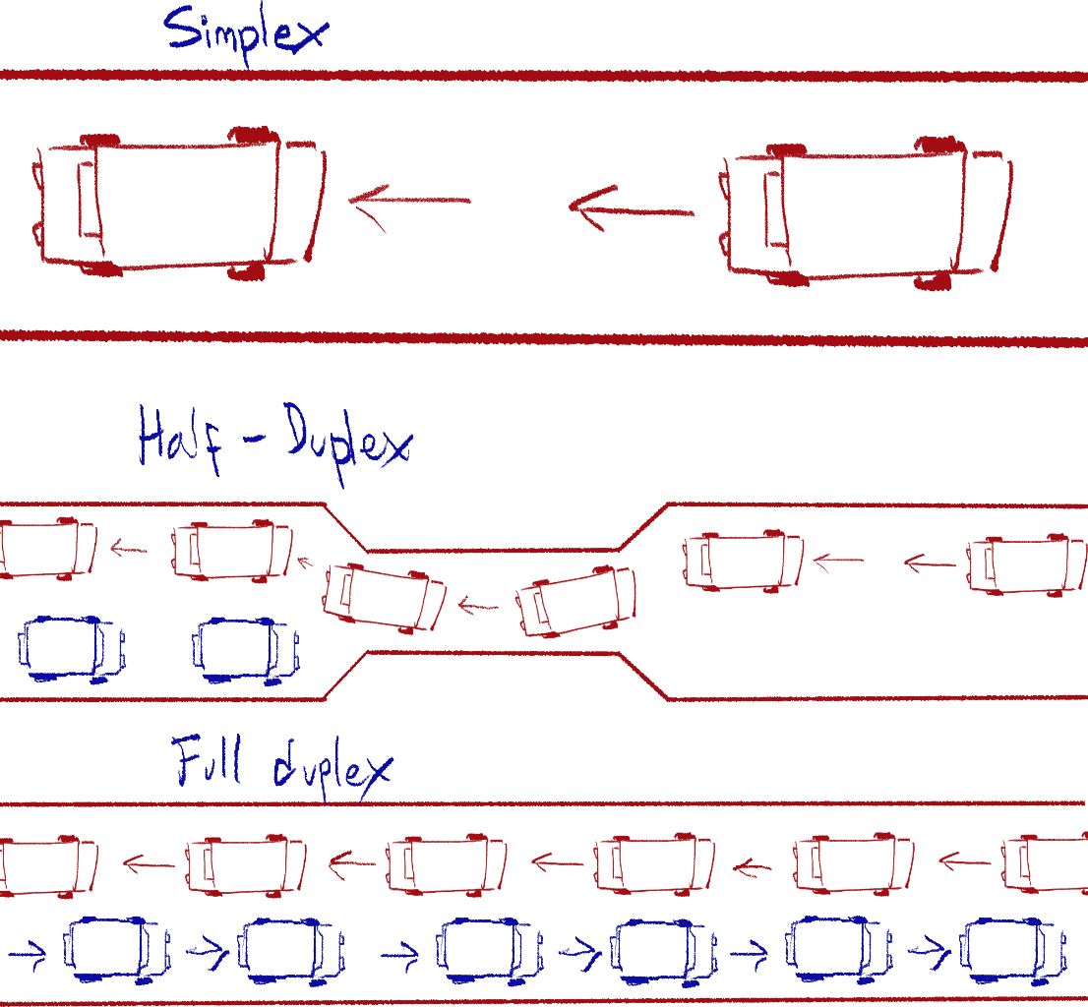Simplex, half-duplex and full-duplex

In simplex transmission, data travels in only one direction. There is a clear sender and receiver device/component. The sender cannot receive data, only send, and vice versa for the receiver.

Examples of simplex transmission include mouse to computer, keyboard to computer, remote to TV, etc.

Half-duplex transmission enables data to be received and sent to either side, but only one side at once. So, if Device A was sending data to Device B, Device B cannot send any data to A.

An example of half-duplex transmission are walkie-talkies. It works almost like taking turns.

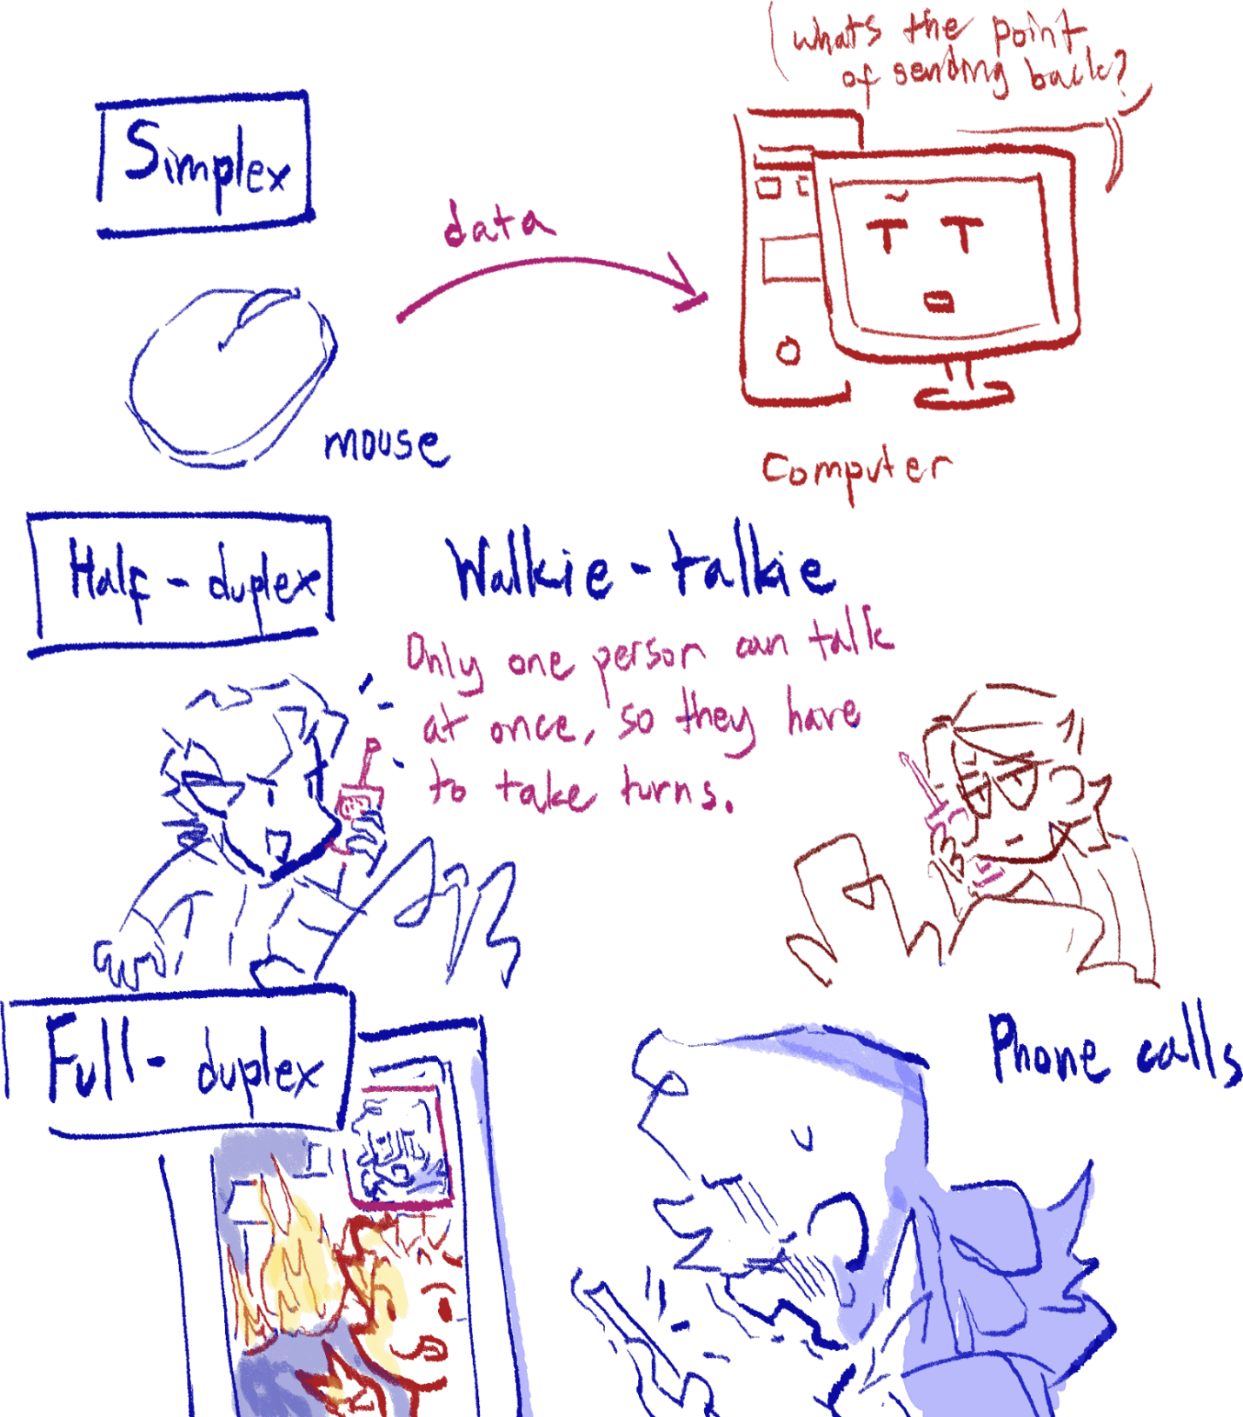Full duplex transmission allows for sending and receiving data on either side, at the same time. An example of this are phone calls – both people can talk at the same time, unlike walkie-talkies. Ethernet connections and fiber optic cables are also included.

USB cables

You’ll need to know some points about them.

* Short for Universal Serial Bus
* Can charge devices while transferring data
* Can be plugged in while device is still running
* Doesn’t break easily because it uses metal contacts instead of pins
* Fast transmission speed
* Cannot be inserted incorrectly
* Automatically detects device and downloads drivers
* Universal standard
* Data is less likely to be corrupted since it’s serial

Error Checking Methods

Reasons for errors and what can happen

May be caused by:

1. Electrical interference
2. Power surges
3. Wire and cable wear and tear
4. Synchronization issues

Possible effects:

1. Data is lost
2. Data is gained
3. Data is changed

Parity bit

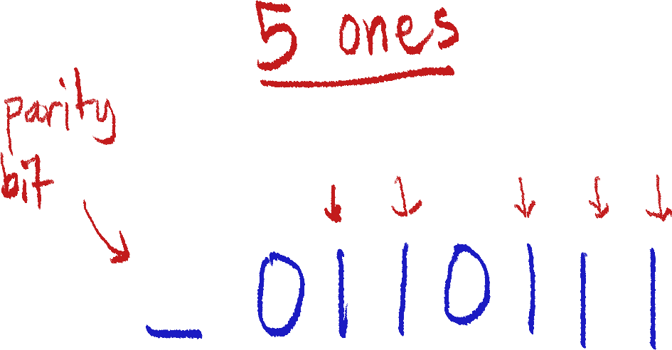 In this method, the last or first bit of a string of bits is used as the parity bit. It is first decided whether to use even or odd parity, and once that is settled, the number of 1s of the bits besides the parity bit is counted. The next step is as follows.

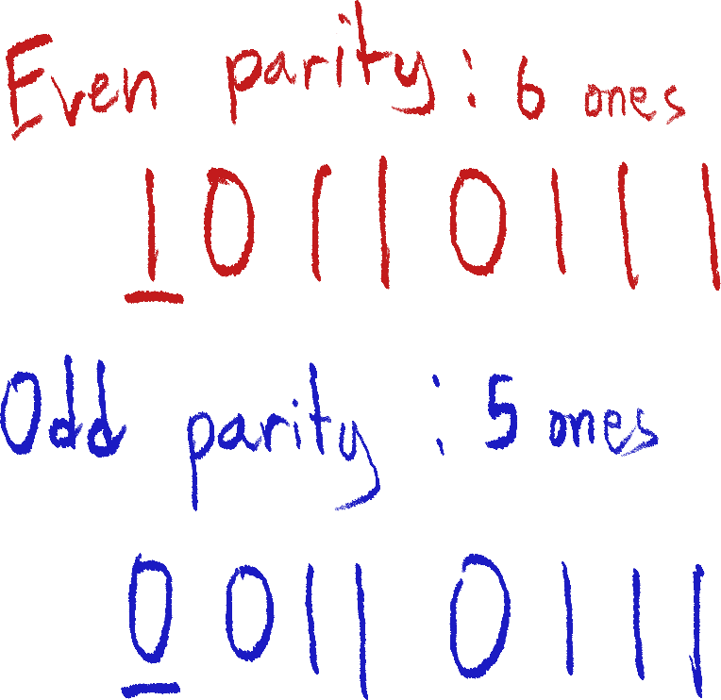We will be using this byte as an example. Let’s say we decided to use even parity for this. Counting the 1s, there are 5. That is odd, so in order to make the number even, we make the parity bit 1 to sum all the 1s into 6, which is even.

If it were odd parity, the parity bit would be 0 as 5 is already odd.

The parity is decided before the file is transmitted, so if the data has been tampered or changed during transmission, the incorrect byte can be found if it does not line up with the parity.

Parity block check

This is a kind of extension of the *parity bit* method, as *parity bit* can only find the byte of the error, but not the specific bit. Parity block fixes this by having a last parity byte at the end, which is essentially made up of parity bits for columns of bits, bytes being rows.

Example below.

I tried making among us

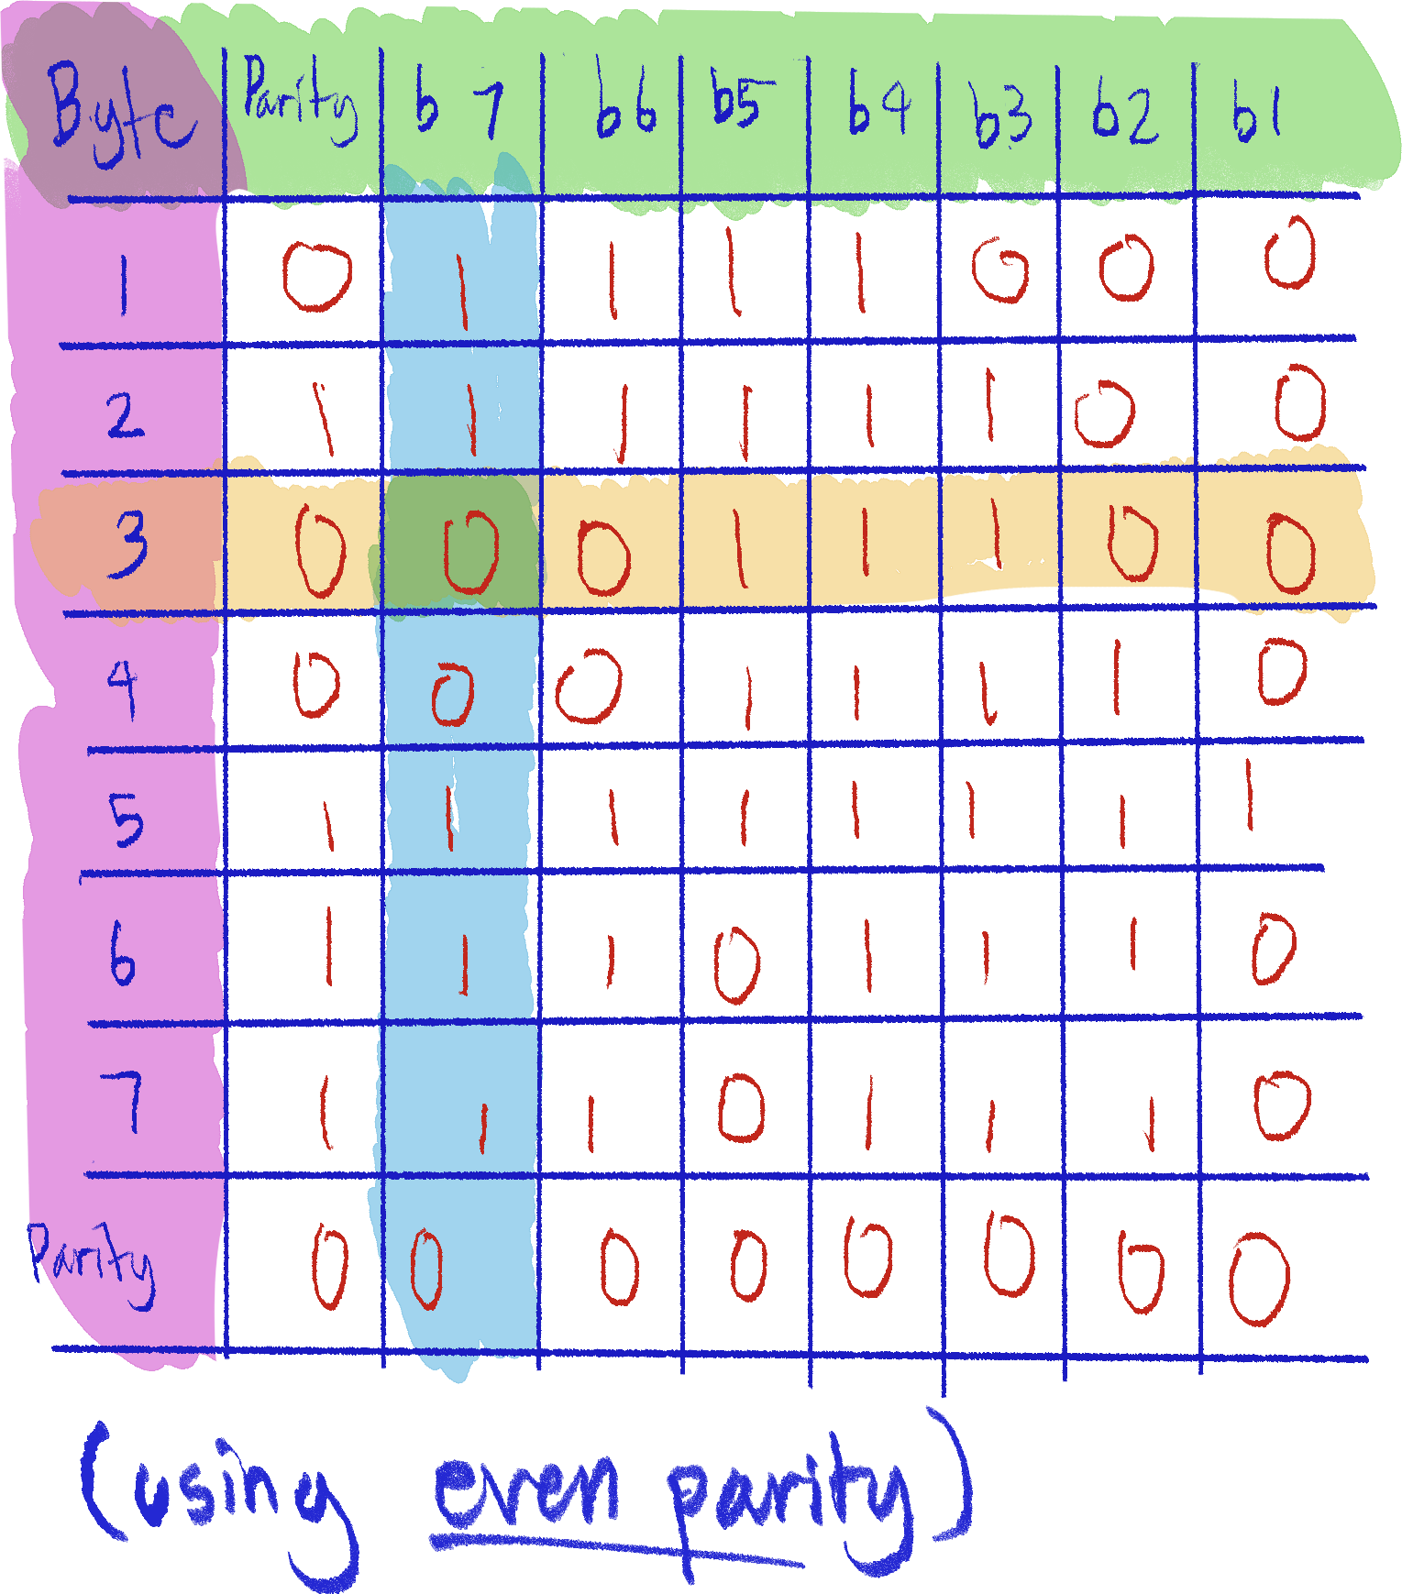This way, the specific incorrect bit can be found.

Checksum

A file can use its own data in an algorithm to create a checksum value. This value is attached to the file before transmission, and the same algorithm is used again after transmission. If the checksum values are not the same, the data has been changed.

For example, I want to transmit this message without error or tampering;

‘Live, laugh, love’

The algorithm I use is *multiply the number of ‘e’s by 3 and add the number of ‘l’s*. The result would be 9 as my checksum. This checksum value is attached to the file.

I transmit this to my good friend online, but a cheeky little hacker intercepts the transmission and changes the message to:

‘Pee, poo, fart’[7]

This data is run through the same algorithm, and the resulting checksum value is 6. My good friend’s computer compares the original checksum value and the new one, and sees that they do not match. Thus, the computer requests my computer to resend the message.

Of course, checksums used in real life are much more complex and accurate. They are not only used to check for errors, but as well as tampering, like the example case – video game cartridges often use checksums as anti-pirating measures.

Checksums, however, cannot detect where exactly the error or change is, and can only detect if there is one.

Check digit

Check digit is a method mainly used to check for errors on data entry. It will attach a check digit to the end of the string of numbers being checked that is the result of an algorithm the data has been put through, like in checksum.

It will check after transmission/entry if the check digit matches up with the result of the algorithm again, and if not, that means there is an error. Again, check digit can only detect the presence of an error, and not necessarily find it. However, many check digit systems have implemented a way to correct the data on entry.

The most common usages of check digit are in ISBN (International Standard Book Number) book codes and UPC (Universal Product Code) codes.

Echo check

The echo check is also used to check for tampering or transmission errors, but is much simpler. In the process of echo check, after the data has been transmitted to the recipient device, it is sent back to the sender device to check whether the data matches the original. If not, the data is resent.

However, this method is a bit flawed, as it cannot detect exactly where the error is, and which transmission it got corrupted in. Also, the data could have been correct, but the copy of it could have gotten corrupted when sending it back instead.

ARQ (Automatic Repeat Request)

This method is similar to the echo check, but a bit more advanced.

The data is sent in blocks, and once correctly received, the recipient sends an acknowledgement (abbreviated *ACK)*, rather than sending the entirety of the data back.

If the data is never received by the recipient, no acknowledgement will be given. If the sender doesn’t get an acknowledgement for long enough, it is considered a time out and the same data block is resent.

Some systems can send negative acknowledgments (abbreviated *NACK*) as a recipient’s response to data with errors, incomplete data, checksum failure, or unreadable data. This also prompts the sender to resend the same data block.

You must understand for what kind of reasons a block of data can fail to correctly transmit according to what ARQ event has happened.

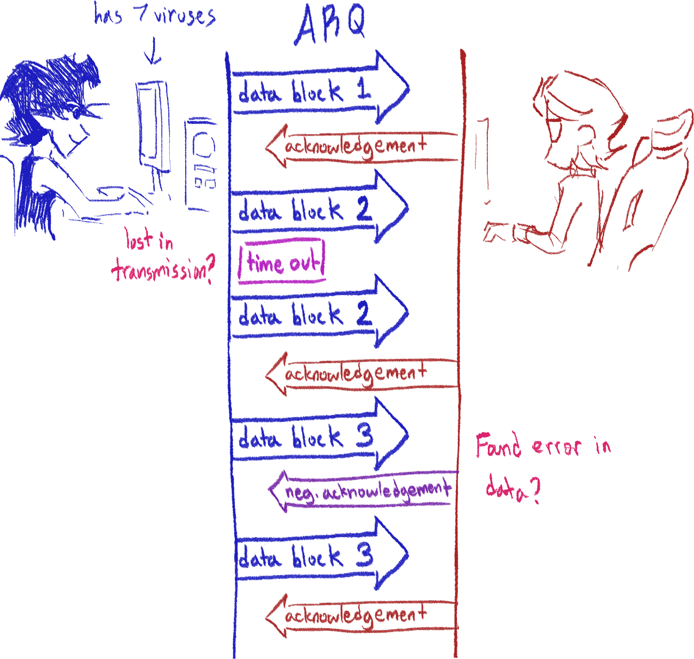Look at the sketch below as an example:

Boolean Logic

Boolean logic is essentially the simplest, most primitive part of computers. Because the electrical signals can only send 1s and 0s, logic circuits are used to process these 0s and 1s into more usable data. Boolean data just means data in the form of only two possibilities, 0 or 1, yes or no, true or false.

a transistor

Logic circuits act similarly to a function in programming; it uses existing variables and processes them either with calculations, comparisons and whatnot, returning a result in the end.

What logic gates are

Logic gates are made up of transistors, and are used to carry out logical operations by controlling the flow of electricity, taking an input and applying its logic to produce an output.

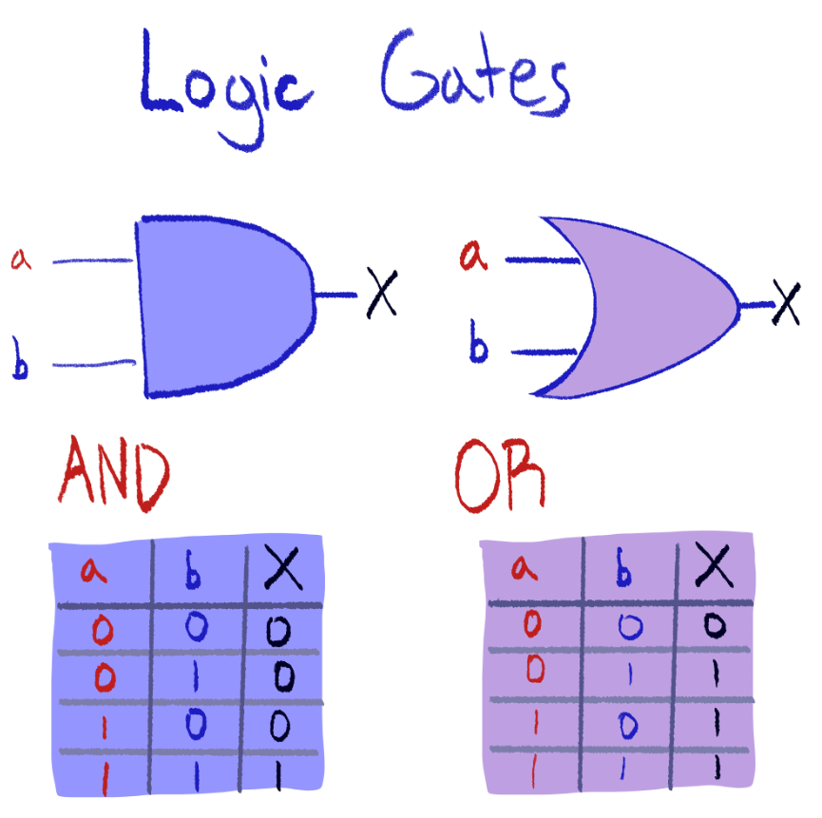All the types of logic gates

The first two gates here are the AND and OR gates (notice that the names are capitalized).

The truth table under each gate shows each possibility of the two inputs, and the result on the same row as X.

For example, if you input 1 and 0 into the AND gate, you can see in the truth table that the output will be 0.

You can think of AND and OR like this: AND only outputs 1 when both inputs are 1. OR outputs 1 if one or more inputs are 1.

NOT is the only gate here that uses only one input. It’s simple – any input that goes through it is flipped. 0 becomes 1 and 1 becomes 0.

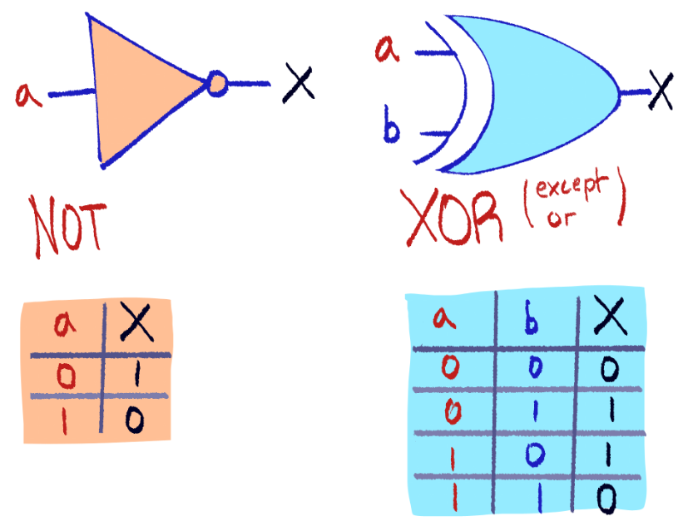XOR is short for ‘except or’. It’s just like OR, except only when one of the inputs are 1, then it will output 1. If both inputs are 1 or 0, then it will output 0.

NAND and NOR are just AND and OR with the output results flipped. That’s it.

You should remember how each gate works and is drawn, to make it easier to work with logic expressions and drawing circuits.

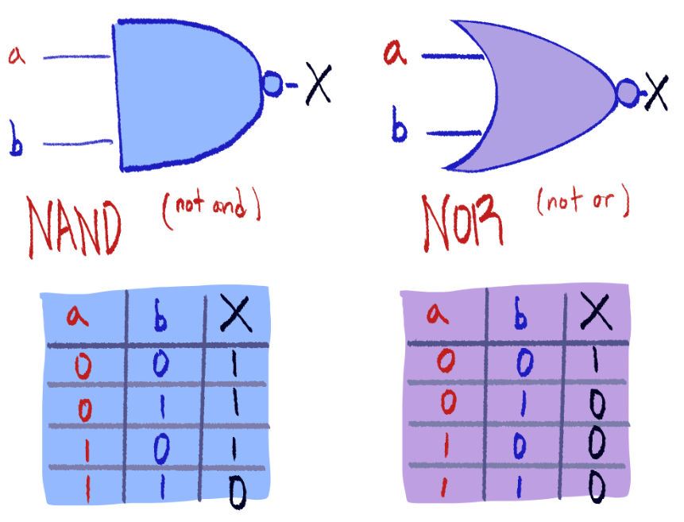

Logic expressions

Look at this logic expression:

(A AND B) OR (NOT B) = X

A and B are the inputs, while X is the final output. The expression means that A AND B is first found, then NOT B. Then, the results of those two gates are put into an OR gate. The final result is X.

You may be asked to fill in the truth table for a logic expression. To do this, first, you should write in all possibilities for the inputs, in this case, A and B.

|  |  |
| --- | --- |
| A | B |
| 0 | 0 |
| 0 | 1 |
| 1 | 0 |
| 1 | 1 |

This part of the truth table will tell you whether the inputs on this row are A=0 and B=0, or A=0 and B=1, and so on.

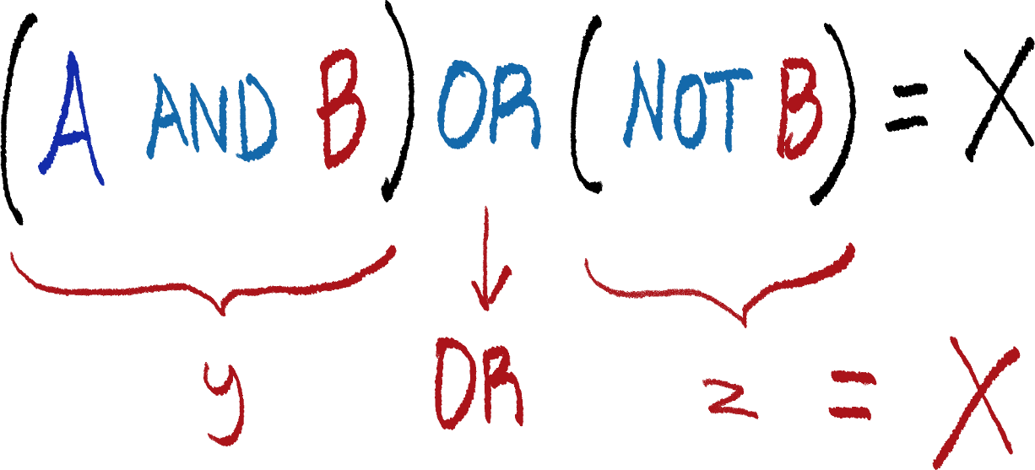Now, we will split up the logic expression to make it easier to digest.

We have made new variables called y and z, to break down the parts of the expression. So, y OR z will be X.

Let’s try this with A = 1 and B = 0.

y = 1 AND 0 = 0

z = NOT 0 = 1

X = y OR z = 0 OR 1 = 1

|  |  |  |  |  |
| --- | --- | --- | --- | --- |
| A | B | y | z | X |
| 0 | 0 | 0 | 1 | 1 |
| 0 | 1 | 0 | 0 | 0 |
| 1 | 0 | 0 | 1 | 1 |
| 1 | 1 | 1 | 0 | 1 |

This can be done until the entire truth table is filled.

Logic circuits

So, now you are asked to draw the logic circuit of this logic expression. This is where you must use your knowledge of drawing the logic gates.

It is recommended you draw the circuit from right to left, as is about to be demonstrated here.

First, find the gate that directly outputs X, the final result. In this case, this is OR.

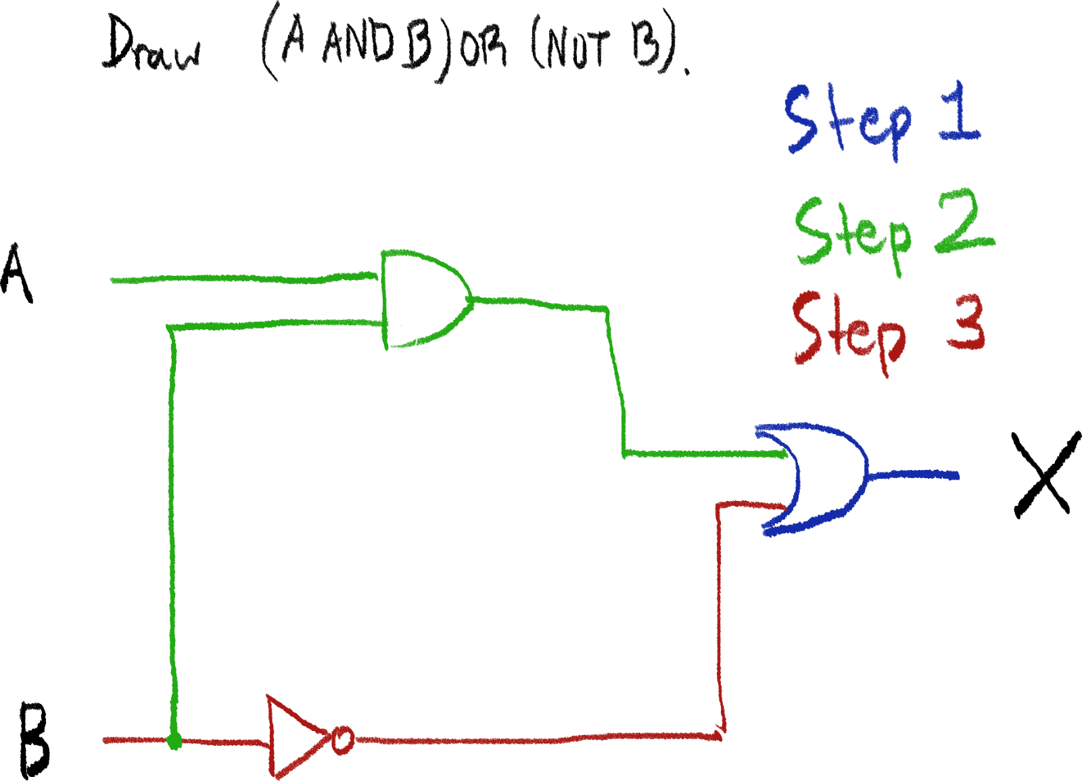Next, find the next gates which outputs become the inputs for OR, and draw them. This process of branching out will continue until you’ve formed the entire circuit.

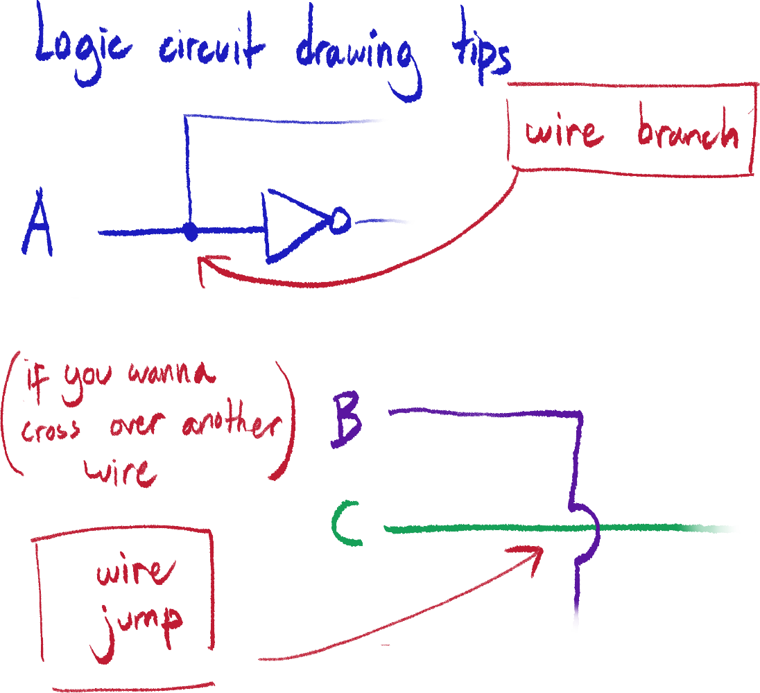



Finding the logic expression of a truth table

(Method: PoS/Product of Sums)

|  |  |  |
| --- | --- | --- |
| A | B | X |
| 0 | 0 | 1 |
| 0 | 1 | 0 |
| 1 | 0 | 1 |
| 1 | 1 | 1 |

You may be asked to find the logic expression of a truth table like this.

To do this, you must first find all X (final output) results that are 1. In this case, it is row 1, 3, and 4.

Now, you must find a way to make the relation between A and B in each row result in 1 using an AND gate. Here is what it will look like:

(NOT A) AND (NOT B)

A AND (NOT B)

A AND B

Now, all you need to do is join these separate expressions using OR gates. It will look like this:

((NOT A) AND (NOT B)) OR (A AND (NOT B)) OR (A AND B)

Databases

A database is a structured collection of data. It is made up of tables, displayed as charts of columns and rows.

Inside a table, there are fields, which are usually considered the category of data the column is defined as. The field is usually named at the first row of the column.

A row in a table (besides the heading row) is called a record, because all the data in the same row refer to a certain instance which all of them are related to.

|  |  |  |
| --- | --- | --- |
| Name | Age | Cool |
| Marley | 3 | yes |
| Lotte | 1 | no |
| Mr. Fuzzle | 5 | no |
| Bibble | 20 | yes |

This is a table, named DOGS.

The first record’s name is Marley, and we can see from the fields that its age is 3 and it is cool.

Oftentimes, records in databases will have a field for code numbers or letters, called a primary key. This is because there may be multiple records of similar data; i.e. there can be multiple people named Josh, and it can be hard to find a specific Josh.

Primary keys can uniquely identify each record, so if you wanted to find a specific Josh which you know the key of, you could search for the Josh with the primary key 120 and find his data.

Data types

There are multiple data types in databases, in order to be able to properly process the data.

* Alphanumeric/text

Data that can contain multiple alphabetical letters and numbers. In SQL (and pseudocode), must be stated with “ “.

Example: WateredDownKetchupDrinker1283

* Character

Like alphanumeric, but can only have one character; letter or number. In pseudocode, must be stated with ‘ ‘, but I don’t think you need to do that for SQL.

Example: p

* Integer

Whole numbers, includes negative numbers.

Example: -643

* Real

Numbers with decimals, can also be negative.

Example: 50.5

* Boolean

Only two possibilities. Yes or no, true or false, 0 or 1, etc.

* Date/time

Just date or time.

Example: 07,05/2024, 10:35

SQL

SQL stands for Structured Query Language, and is used for most types of databases to:

* Define tables
* Change tables
* Add data to tables
* Search data from tables (query)
* Calculate using table data

Here, we will review how to make SQL queries and simple calculations.

SELECT (selects field(s))

FROM (selects table)

SELECT should always be put before FROM. Order for all these commands should be consistent like this.

Using the DOGS table, if I wanted to find and display all dogs’ names and ages, I would make this query:

SELECT Name, Age

FROM DOGS

It is important to keep all spelling and capitalization the same. The result of this query will be:

Marley

Lotte

Mr. Fuzzle

Bibble

3

1

5

20

WHERE is used to filter and pick out records according to a defined criteria. For example, If this is my query:

SELECT Name, Age

FROM DOGS

WHERE Cool = yes AND Age > 5

This will be the result:

Bibble

20

For the alphanumeric data type, remember to put quotation marks, like this:

WHERE Name = “Marley”

Equal to: =

Not equal to: <>

Less than: <

Less than or equal to: <=

Greater than: >

Greater than or equal to: >=

AND is used between criteria to select only records that follow both.

OR is used between criteria to select records that follow either.

ORDER BY simply orders the displayed items ascending (ASC) or descending (DESC) according to the field you order them by.

SELECT Age

FROM DOGS

ORDER BY Age DESC

Will result in:

20

5

3

1

SUM, not to be confused with COUNT, adds the data, integer or real, of the SELECT field.

SELECT SUM (Age)

FROM DOGS

WHERE Age < 20

Will result in:

9

COUNT is structured similarly to SUM, but instead only counts the number of records.

SELECT COUNT (Age)

FROM DOGS

WHERE Age < 20

Will result in:

3

The Internet and World Wide Web

Difference between the Internet and World Wide Web

Although the two terms are used interchangeably, they have different roles:

The Internet

The Internet is more of a general concept that refers to the underlying physical infrastructure (certain underground cables) that connects devices everywhere – a global network. The Internet mainly uses IP as its protocol.

The World Wide Web (WWW)

WWW is a software service that is part of the Internet and is constructed of URLs to locate data and webpages that are written using HTML. Web browsers are used to access the WWW. WWW mainly uses HTTP and HTTPS as its protocols.

Internet services separate from WWW include emailing and chatting.

IP

IP stands for Internet Protocol, and is a set of rules for how the Internet manages data transfers – such as data packet switching and the use of IP addresses. The data packet stuff we learned earlier was a part of IP.

IP addresses

IP addresses are addresses that uniquely identify a device on a network, and is used for online data transmissions. IP addresses can be static or dynamic, which means they can be set or they can change.

IP addresses are usually shown in small groups of digits, separated by full stops or colons.

IPv4

IPv4 is an older version of IP address that uses 32 bits, but isn’t used now. Bits are written in 8 groups of 4.

1111 : 0000 : 1111 : 0000 : 1111 : 0000 : 1111 : 0000

IPv6

IPv6 is the current version of IP address that uses 128 bits, to account for the larger amount of people using the Internet. Because of how long it is, it is often represented in hex as 8 groups of 4 hex digits.

A123 : B123 : C123 : D123 : E123 : F123 : ABCD : ABCD

MAC addresses

MAC stands for Media Access Control, and MAC addresses are also used to identify devices on a network, but is unique to the specific device and cannot be changed for that device, as it is set by the manufacturer.

Think of it like IP addresses are used specifically for the online transmissions, while MAC addresses more accurately identify the physical device.

MAC addresses are made up of 48 bits, but are usually represented in 6 pairs of hex digits.

The first half of a MAC address identifies the manufacturer of the device, while the second half has its serial number.

AB - CD - EF – AB - CD - EF

HTML, URLs and web browsers

HTML stands for HyperText Markup Language and is used to create webpages, though usually along with CSS and JavaScript.

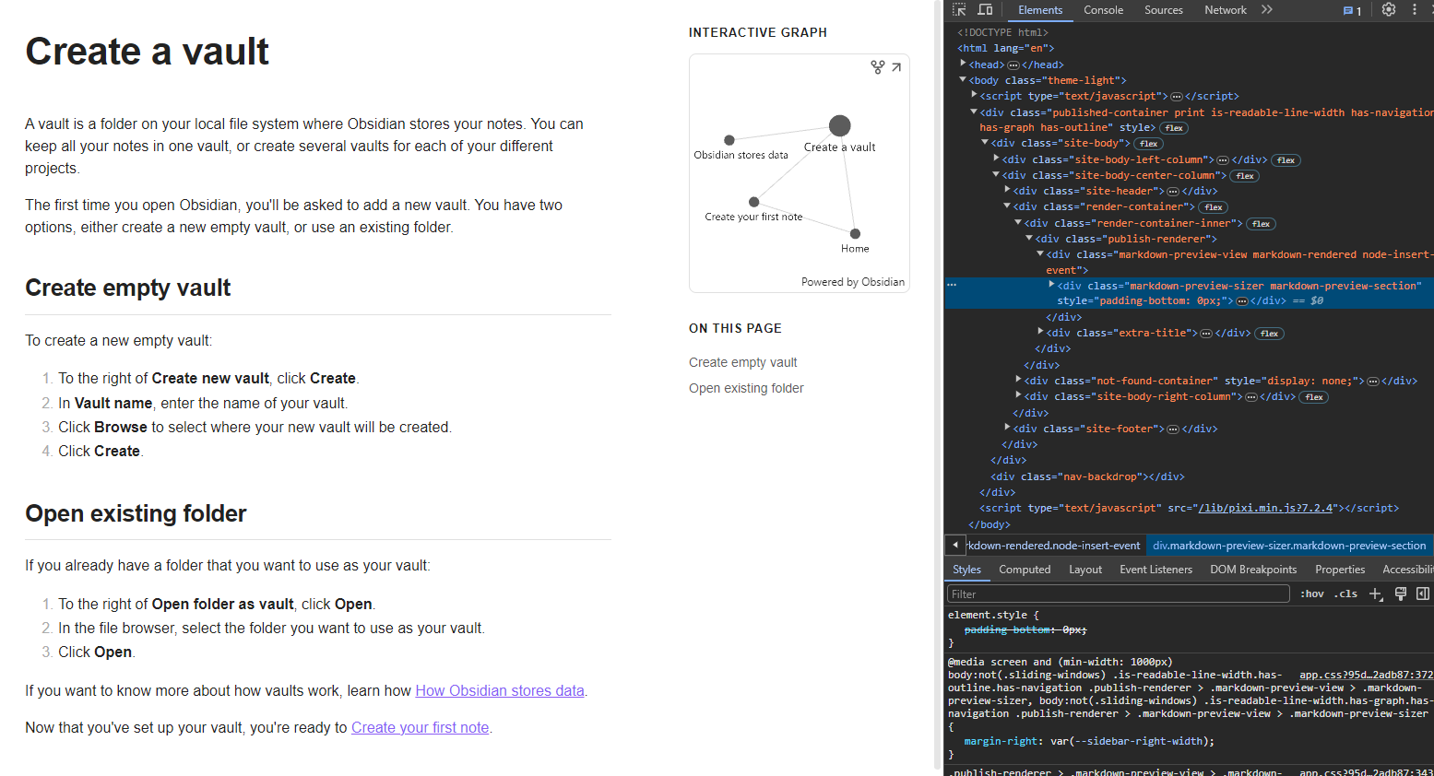

Example of a webpage with the HTML script used to display it.

URLs stand for Uniform Resource Locator and are used to locate webpages and files on the Internet.

Here is the structure of a URL:

https://fart.com/images/ImageOfFart.png

https: - protocol

fart.com – domain name

/images/ImageOfFart.png –path

ImageOfFart.png – file/webpage

A web browser is a program that connects to DNS servers using the URL and fetches files from the IP of the website, then renders HTML for webpages.

Other stuff include:

* Stores bookmarks, extensions and passwords
* Records browsing history
* Checks protocols and digital certificate
* Allows use of multiple tabs
* Provides navigation tools
* Provides address bar
* Runs JavaScript

HTTP and HTTPS

HTTP stands for Hyper Text Transfer Protocol, and is a set of rules used by the WWW to transfer files through the Internet. HTTPS simply means HTTP Secure, and is the same except it also uses encryption to keep files secure.

HTTPS usually uses SSL (Secure Sockets Layer) or TLS (Transport Layer Security), the latter protocol being the most often used these days, to keep file transmission secure.

This is done by the use of digital certificates[8]. With all transmissions encrypted, the browser will request the web server for its digital certificate. As the certificate contains the website’s public key, it can be used to authenticate the website. Once authenticated, the browser and server agree on an encryption method, and a session key is generated. Finally, encrypted data transmission is allowed between the browser and server. This is how SSL works.

One can see whether a webpage is secure by:

* 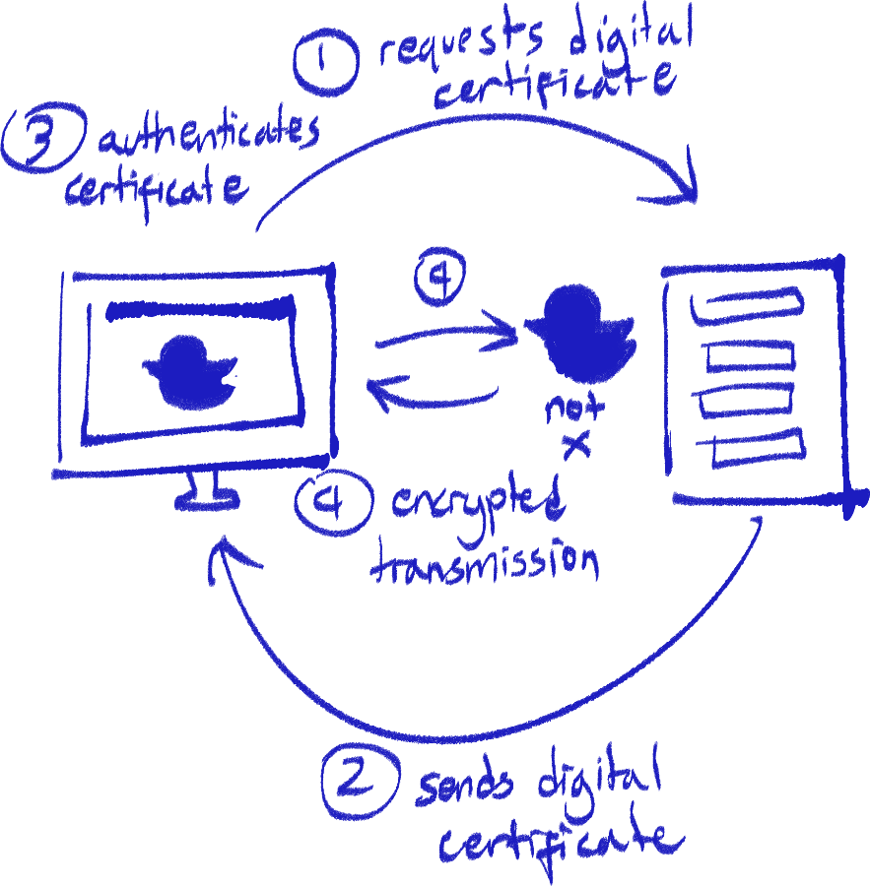Checking for a padlock symbol on the web browser
* Checking the URL’s protocol – it should be HTTPS
* Checking the digital certificate of the website

Retrieving web pages

Domain names in URLs, though signifying the website’s particular server, does not directly lead to it. Rather, the domain name’s corresponding IP address must be found by the browser in order to communicate with the server.

To achieve this, servers dedicated to storing domain names along with their IP addresses for websites exist, called DNS (Domain Name Server) servers. So, the browser sends a request to a DNS for the IP address to a URL, and the DNS will send it to the browser.

Sometimes, the requested DNS server will not have the domain name asked for in its database. In this case, it will communicate with another DNS server for it. Once found, the second DNS sends back the IP address for the first DNS, and it will save it in its database and send it back to the browser.

Thus, the browser, using the IP address, can communicate with the website server and render the webpage for the computer. (sorry for whatever the hell this diagram is cause they genuinely ask for diagrams like that)

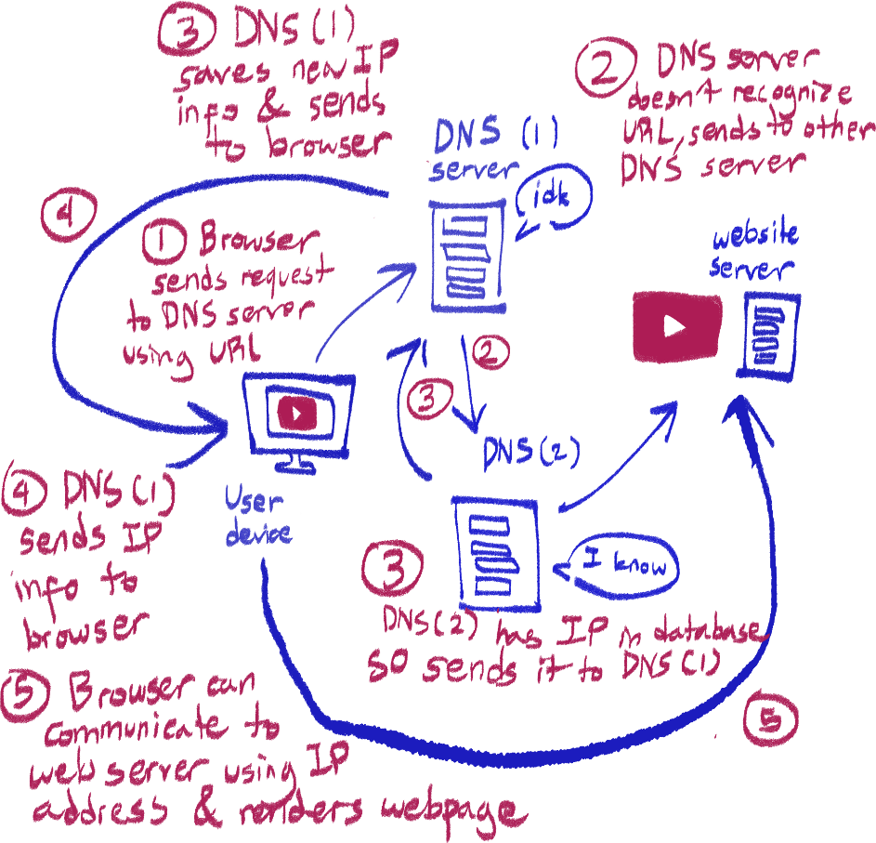

Cookies

Cookies are small text files stored by the browser. Cookies are often used to store information so you don’t have to input it again even after you leave the site. Uses include:

* Storing user details and info
* Storing user preferences (font, theme, etc)
* Tracking user statistics (new or returning visitor)
* Storing login details
* Pushing targeted ads

However, cookies can also invade many people’s privacy, to the point it can increase the risk of identity theft. To tackle this, cookies and cache use should be limited by configuring the web browser.

Session and persistent cookies

Session cookies only exist for as long as the browser session its associated with is open. Once the session expires, the session cookies are deleted. Keyword is temporary.

Persistent cookies exist for a time after the session expires. Usually, there is an expiry date for these, and are deleted then. Keyword is permanent.

Cryptocurrency

According to our book, cryptocurrency or digital currency is a currency that exists solely electronically. Examples include Bitcoin and Ethereum.

Features that differentiate it from normal currencies are:

1. It is decentralized (not overlooked by any greater authority)

stupid monkey nft

1. Transactions are public
2. Uses cryptography to store transactions (are encrypted)
3. Uses the blockchain

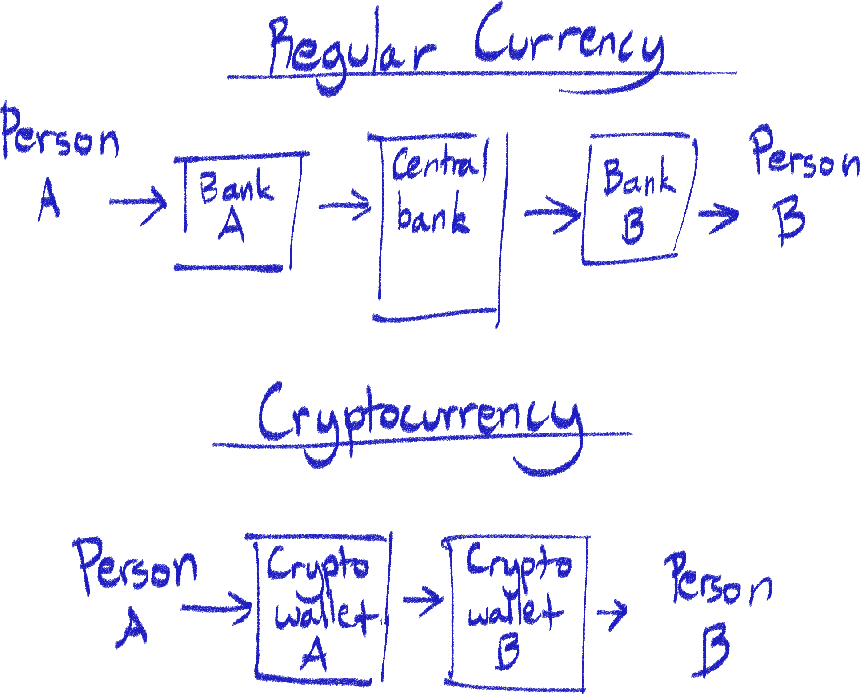

Diagrams depicting money transactions with regular currency and cryptocurrency.

Blockchain basics

The blockchain is a technology based on the ledger system where all records of data are time-stamped and placed chronologically to each other in ‘blocks’ of data, with changes and additions being added in new blocks. No actual alterations of data are possible.

Compared to the database system of recording, the blockchain system can be considered more reliable as all changes and additions can be traced, and nobody can manipulate it.

Block components

1. Its hash value

The hash value is calculated by putting the data in the block through a hashing algorithm. If the data is changed, the hash value will be invalid and must be recalculated.

1. The previous block’s hash value

Refers to the hash value of the block preceding it. If not found, the blockchain will be unlinked.

1. The block’s number

The block’s number according to its order in the blockchain.

1. The timestamp

The date and time the block was created.

1. The transaction data

Blockchain security

Peer-to-peer

This is a method of authentication most blockchains use, where all users of the blockchain get a complete copy of it. If a new block is made, a copy of the blockchain with the new block is sent to everyone in the network to be verified. So, if a fraudulent version of the blockchain was created, it can be compared to all other copies of the blockchain on the network.

Hash number

Because each block is linked to the block preceding it by hash number, if any blocks are altered, its hash number must be recalculated and thus it will be unlinked to the block after it.

Cryptography

The addresses of the sender and receiver of the transactions are stored in the transaction details, and because of the use of cryptography, they can be verified through the use of their public keys.

How blocks are made

Blocks are made by solving mathematical problems, done by computers. This is called mining, and when miners solve a problem to create a block, they are usually rewarded in digital currency, such as Bitcoin.

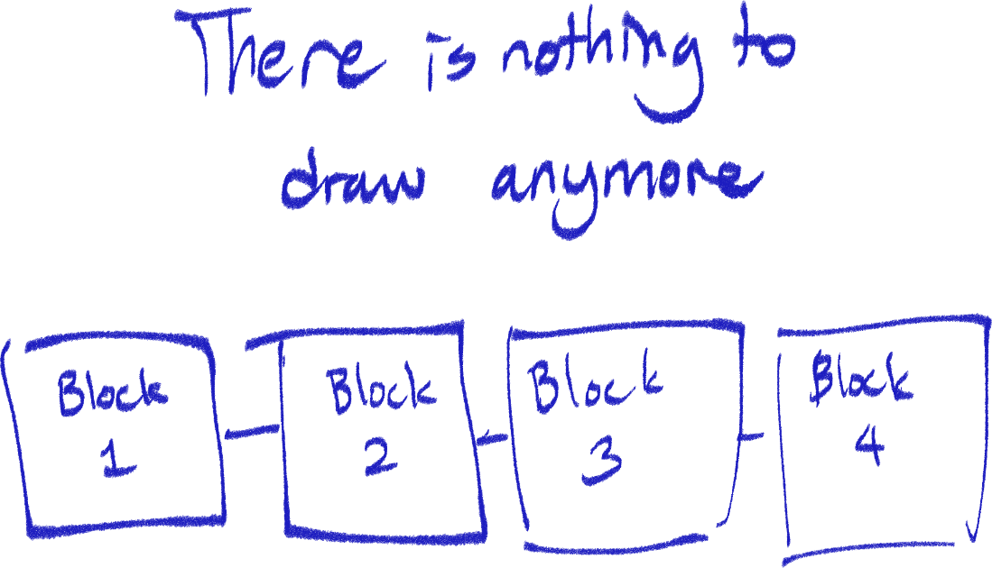

Cyber Security

Threats

Social engineering

Social engineering is the method of manipulating individuals to gain information or trick them into doing something.

This can include fake emails asking for personal information or calling the individual under the pretext of a trusted organization or a relative.

Phishing

Phishing is a type of social engineering where the perpetrator sends legitimate-looking emails to the user, that encourages the user to follow links to fake websites designed to collect personal and important information.

Pharming

Pharming uses malware installed on the user’s system without permission to redirect legitimate URLs to fake websites in order for the user to input personal information.

Malware

Malware is software intended to harm or gain access to a device without permission. Types include:

* Virus

A virus replicates itself in the device to slow it down, corrupting and deleting files on the computer.

* Worm

A worm looks for vulnerabilities in the device’s network and replicates itself there to slow the network down – reduces bandwidth.

* Trojan

A trojan is a program appearing like a regular program, but actually contains malware.

* Spyware

Spyware is a program meant to track and record user activity. This is often in the form of a keylogger that records the keyboard signals being input into the computer, and sends the logs to a third party to be analyzed. A password or other detail can then be found be finding a pattern or common string within the logs.

* Adware

Adware is a program that pushes unwanted advertisements onto the device without consent, usually in the form of pop-up windows, so the adware developer gets advertisement income.

* Ransomware

Ransomware encrypts the user’s files and asks for ransom in exchange for the decryption key.

DDoS attacks

DDoS (Distributed Denial of Service) attacks uses a network of multiple controlled devices called a botnet to send many requests to a server at once so that there are too many for the server to process, causing it to crash.

Hacking

Hacking involves exploiting vulnerabilities in a network or system to gain unauthorized access to it. Thus, the hacker can steal, corrupt or delete data in the network or system.

Brute-force attack

A brute-force attack involves using a software program to generate and input passwords to get unauthorized login access by trial-and-error.

Having a longer password with words that can’t easily be guessed can reduce the chance of a successful brute-force attack. Two-factor authentication and password input limits also help.

Data interception

In this case, an attacker can use a program called a data packet sniffer to analyze data transmissions on the network it’s connected to. The data packets can then be analyzed to find confidential information.

Best solution is to always use secure data transmission with encryption.

Solutions and counter-measures

Antimalware

An antimalware program is software that has a database of known malicious files and programs and searches for them in the user’s computer. Once malware is found, it quarantines it and asks the user to delete it.

It is advised to regularly update antimalware programs to avoid the risk of being targeted by any new vulnerabilities.

Firewall

A firewall is an application that monitors data traffic. It allows the setting of criteria, and blocks access to signals that do not follow that criteria. When that happens, it warns the user about it.

It can also restrict access of signals for specific programs and block exit and entry of signals through certain ports.

Proxy server

To tackle DDoS attacks, most web servers have proxy servers that act as an intermediary between the user and web server. They filter traffic, relaying valid requests to the web server and denying invalid requests. It can also cache IPs – if a single IP sends too many, requests, it will block it. Firewalls are often also used to prevent DDoS attacks.

Tackling social engineering

* Check if emails are personalized
* Check for grammatical and spelling errors
* Check if website URL is correct
* Use access levels (certain people can only access certain things)

Encryption

Encryption involves using an algorithm to turn plain text into cipher text, so that the data is meaningless to anyone that steals it. The algorithm is called an encryption key, and in order to decipher the data, one needs a decryption key. Encryption is often used for protecting data from unauthorized parties.

There are two types of encryption:

Symmetric encryption

In this type of encryption, the same encryption key can be used to both encrypt and decrypt data. For example, one person encrypts a file and sends it to their friend. The friend receives the same encryption key to decrypt that file on their end.

However, using symmetric encryption can mean that anyone that receives the encryption key can understand the data, and it is easy to distribute a key.

Asymmetric encryption

In asymmetric encryption, every user has a public key and a private key. The public key is the encryption key, and the private key is the decryption key – these are separate, and can only encrypt or decrypt, but not both. As their names suggest, the public key is known to everyone, while the private key is only known by the user.

If person A wants to send a file to their friend, B, they encrypt the file using B’s public key before sending it. Since nobody else has B’s private key, only A (who sent the original file) and B (who can decrypt the file) knows the actual data.

Besides sending files and data, asymmetric encryption is also used to authenticate users’ and servers’ identities, since public keys are unique to each person – if you are able to decrypt something encrypted by the public key in your name, that proves that it is you.

Strengthening encryption

* Using a longer length for the encryption key
* Using a more complex encryption algorithm

Software Development

Software development lifecycle – Waterfall

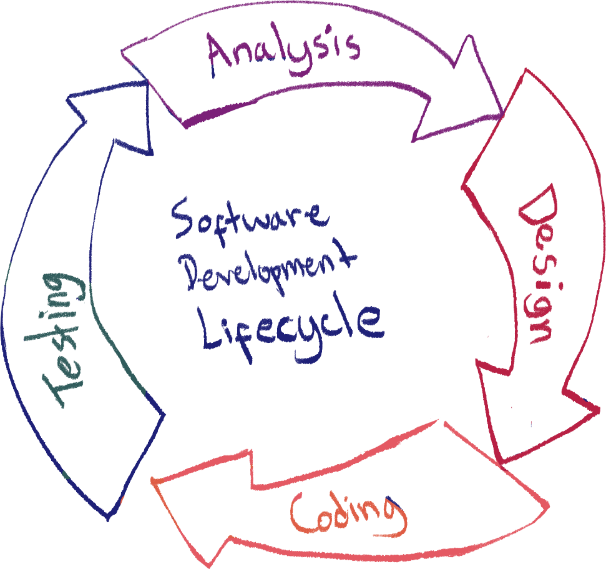

This is just the cycle that is undergone for software development.

Analysis includes:

* Identification of problem
* Decomposition of problem
* Abstraction
* Outline of success criteria

Design includes:

* Deconstruction
* Flowcharts
* Structure diagrams
* Pseudocode

Coding includes:

* Programming
* Iterative testing (testing while writing code)

Testing includes:

* It’s just testing

Structure diagrams

Structure diagrams are just a way of deconstructing and separating the different aspects and features of a program. The features can be broken down into 4 categories:

* Inputs
* Outputs
* Storage (optional)
* Processes

Make sure to put the name of the program being designed at the very top of the diagram.

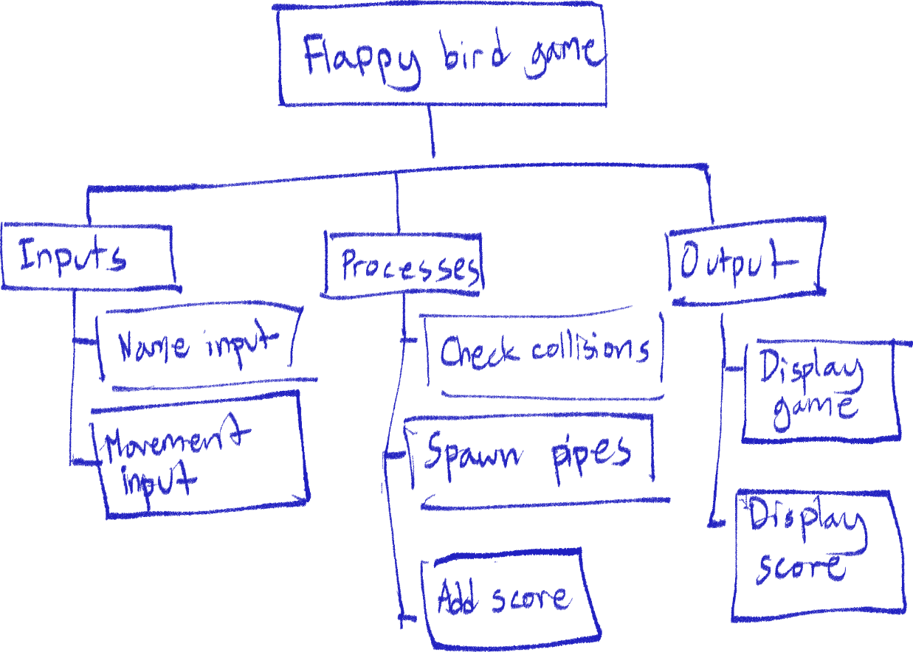

Flowcharts

Flowcharts are used to represent and explain an algorithm visually.

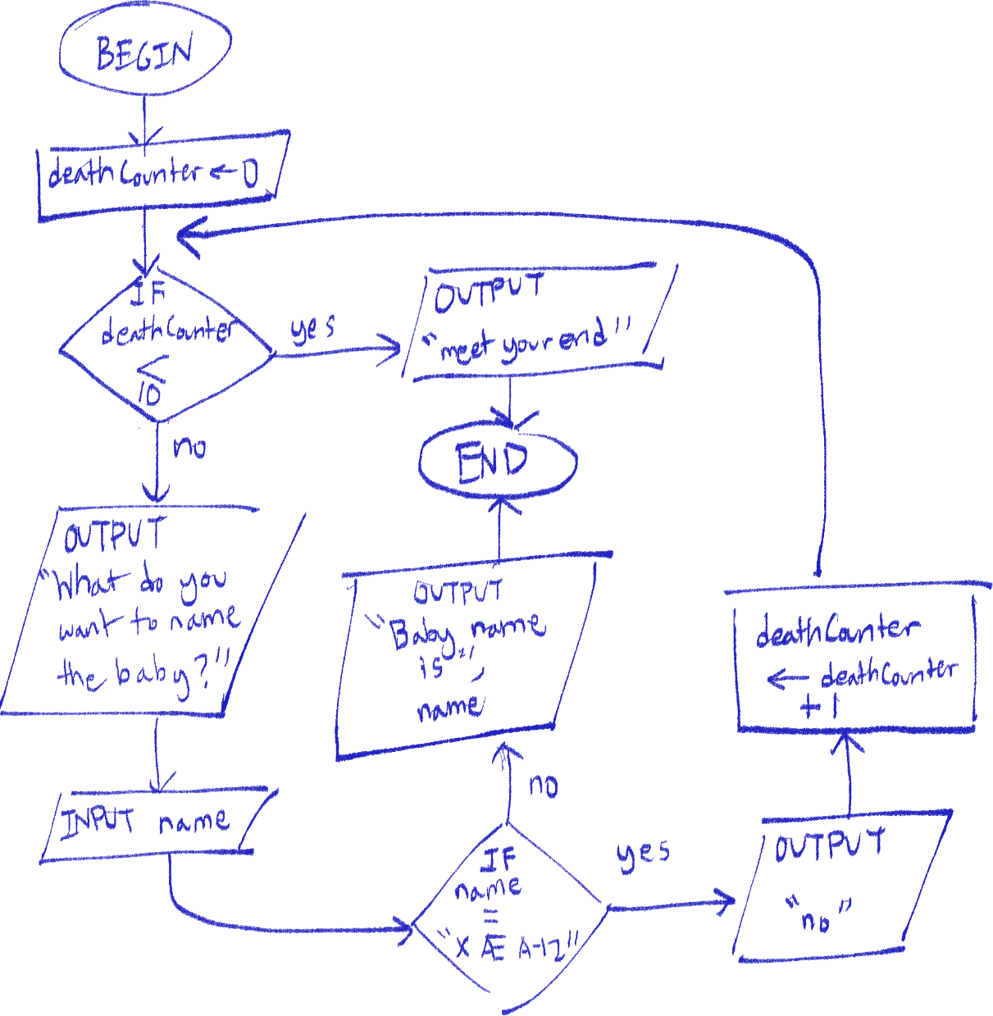

It is important to keep variable names consistent, use keywords and to use double quotes when writing a string.

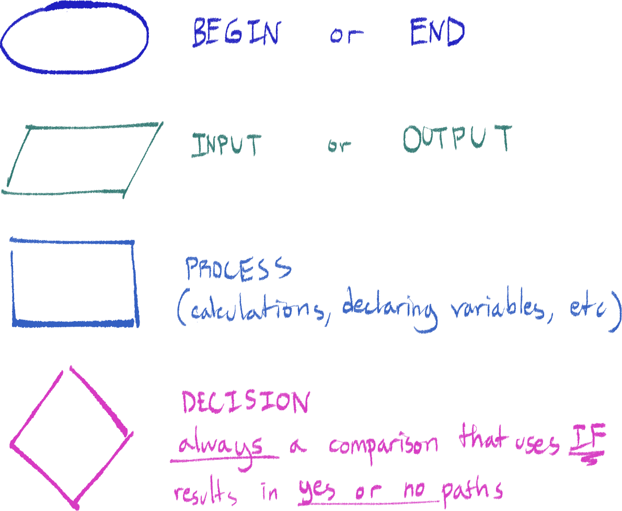

Pseudocode

It’s not a real programming language, but it is used to represent code without worries of correct syntax and small errors, and is meant to be easy to understand for any programmer of any programming language.

None of it will be explained here because the official IGCSE guide for it is very comprehensive and doing it here would be redundant with its existence.

Note that you can literally write in the exam using any scripting language like Python and Javascript (or maybe even make up stuff) and still get full marks, the main thing is that you show you can program well with the appropriate techniques and that it’s understandable (you need comments for a full mark).

Subroutines

Subroutines are used to shorten code and make it easier, more reliable and more dynamically repeat multiple lines of code in a program. Functions and procedures are types of subroutines.

Functions and procedures are virtually the same except functions return a value while procedures don’t.

Data validation and verification

Validation

Data validation tests if data entered into a program is reasonable – for example, making sure a password is valid to use when signing up.

Validation types

* Length (i.e. password must be at least 8 characters)
* Type (i.e. PIN must be an integer)
* Presence (checking if there even is any data – not NULL or “ “)
* Format (Mix of types and/or length, example is that date input must be in dd/mm/yyyy)

Describing validation checks in questions

First, describe exactly what you’re checking for. For example, check that the value input is between 1 and 10 inclusive. Then, say how it could be rejected, such as if the value is above 10, it will be rejected.

Verification

Verification tests that the input is the correct value or value intended to be input – for example, typing in the password twice when signing up in order to make sure you’ve got the correct input.

Ways to verify data[9]

* Visual check (directly comparing data input to the original value, done by a person)
* Double-entry check (entering the data twice (usually by different people) then having a computer check if they’re different)

Testing program data validation

These are some types of data inputs program testers use to ensure the program is working correctly and accepting the correct data, while rejecting incorrect data.

Normal

Data that should be accepted by the program and within acceptance criteria.

Abnormal

Data that should be rejected by the program and outside acceptance criteria.

Extreme

Data that is on the edge of being accepted – should be within the criteria, but it’s very close to being rejected.

Boundary

Inputting two pieces of data that are on the edge of being accepted and on the edge of being rejected, to test that the boundary is at the correct place.

Example

For example, the program we are testing accepts *integers* from *1 to 100 inclusive*:

* Testing for normal input, the tester inputs 1 and 50.
* Testing for abnormal input, the tester inputs -39, “hello” and 10.5.
* Testing for extreme input, the tester inputs 1 and 100.
* Testing for the boundaries:
  + The lower boundary is tested using 1 and 0
  + The upper boundary is tested using 100 and 101.

If the actual results of testing this with the program and the expected results do not align (i.e. the program accepts “hello”, or rejects 100), that means there is a problem with the program and it needs to be fixed in code.

Year 10 Finished!

Unused Illustrations

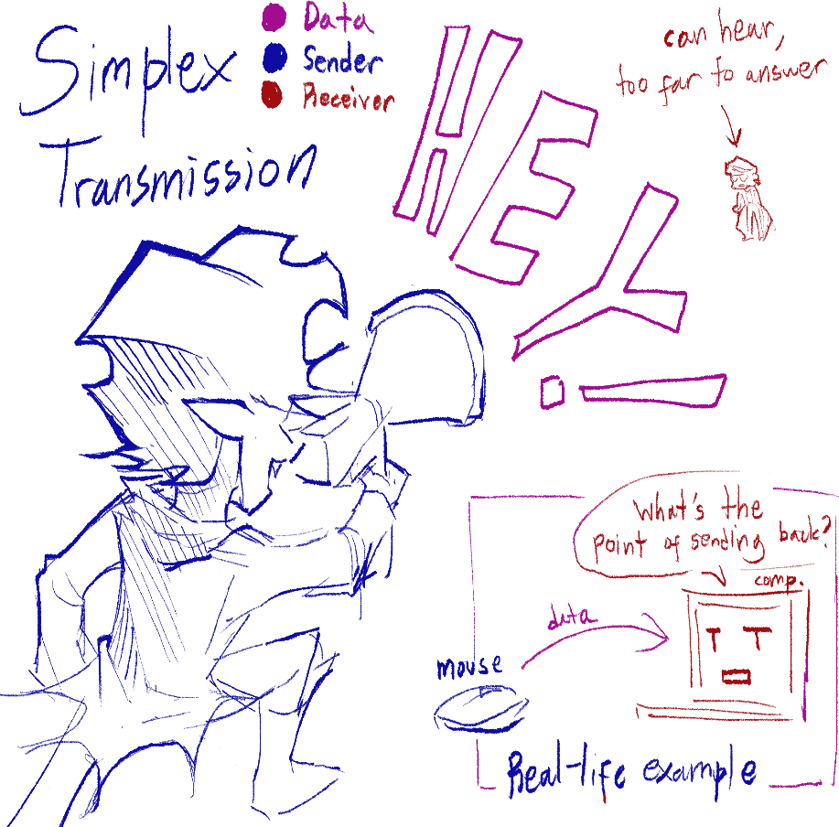

Didn’t know what to do with

these.





Computer Architecture + Data Storage

Intro: microprocessors and CPUs

Microprocessors

Microprocessors are a type of IC (integrated circuit) that exists on a single chip. A microprocessor has all the components to be a CPU.

CPU

CPU stands for Central Processing Unit, and is responsible for processing data, doing logic and calculations using the computer’s data in memory and executing actions, usually giving an output for the computer. This task is called executing FDE (Fetch-Decode-Execute) cycles in short.

Von Neumann architecture

Von Neumann computer architecture is based off the stored program concept, where instructions and data are stored in a main memory unit, separate from the CPU, and instructions/data are fetched one after another.

This concept was developed because early computers where horrible to reprogram – programs were based in the hardware of the computer, and reprogramming meant rewiring the computer. By having programs separate on a memory unit, the computer became programmable.

The main components of Von Neumann architecture are:

* A main memory unit, where data and instructions are stored
* A CPU for processing data
* I/O devices (input and output)

Actually, the components inside the CPU count more as components of Von Neumann architecture than the CPU itself, but this is just an overview.

Main memory

Main memory is where data and instructions currently being processed by the CPU is stored. Another word for it is RAM, and can be described just like RAM in that it is primary memory, volatile memory, and that it is directly accessed by the CPU.

CPU structure and FDE cycle

Address, control, and data buses

A bus is basically a wire connection between computer components so they can communicate with each other. There are different types of buses should know that are relevant to this chapter.

1. Data bus

The data bus will carry data, usually to be processed for calculations or logic. An example could be that there are two numbers in memory that need to be summed up – the CPU will fetch that data from memory through the data bus.

1. Address bus

The address bus carries the addresses to data in memory, the specific location of data in memory. This is needed so that components can easily find the data they need. For example, the CPU will need the addresses of those two numbers to fetch that data from memory.

1. Control bus

The control bus carries control signals, to communicate instructions and commands between computer components and coordinate them.

Other terms you should know

* Data vs instruction

These aren’t the same thing, so make sure you don’t use them interchangeably, even though the CPU processes both of these.

* Register

A type of transistor that carries any type of information, used as temporary memory, usually in small sizes.

Components of a CPU

1. CU (Control Unit)

The CU of a CPU contains the CIR, and is responsible for sending control signals to other parts of the CPU

1. CIR (Current Instruction Register) / IR (Instruction Register)

Holds the data/instruction currently being processed

1. ALU (Arithmetic Logic Unit)

Carries out logic and calculations, and stores temporary values in the ACC.

1. ACC (Accumulator)

Built into the ALU, a register that temporarily holds the result of the calculation

1. Clock

Produces timing signals to ensure all actions are synchronized[10]

1. MDR (Memory Data Register)

Holds the data/instruction that is currently being processed by the CU or data that is about to be written memory by the CPU

1. MAR (Memory Address Register)

Holds the address of the data/instruction that is currently being processed by the CU or the address of data that is about to be written into memory by the CPU

1. PC (Program Counter)

Holds the address of the next data/instruction that needs to be processed. Will increment by 1 (the next instruction to be processed) every FDE cycle.

1. Cache

Holds frequently used data/instructions so that they can easily be fetched by the CPU – the CPU will check cache before fetching data from other memory

FDE cycle – Fetch stage[11]

The fetch stage is the stage where the CPU fetches the data/instructions from memory to be processed. These are the steps: (specifying the bus in important)

1. 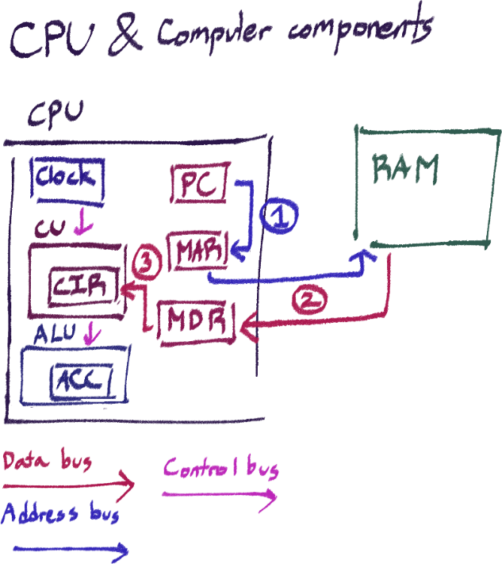The PC sends the address of the data/instruction that currently needs to be processed to the MAR using the address bus. The PC is incremented by one (which means it will now have the address of the next line of instruction for the next cycle)
2. The address from the MAR is used to fetch the data/instruction from memory and copy it to the MDR, using the address bus and data bus respectively
3. The data/instruction from the MDR is sent and stored in the CIR using the data bus.

FDE cycle – Decode stage

Instructions are decoded in the CU using an instruction set, which translates instructions for the CPU. Points for instruction sets are:

1. It is a low-level language that instructs the CPU on how to carry out an operation.
2. It is machine code that can be understood by the CPU.

FDE cycle – Execute stage

The CU just executes whatever they need to do according to instructions, and the cycle is repeated for the next address in the PC.

Factors that affect the processing speed of a computer in terms of CPU

1. Clock speed

The clock speed of a computer determines how many FDE cycles it can execute within a second, so with a higher clock speed, the CPU will have a faster speed. Clock speed is measured in Hertz, so 1Hz means 1 instruction per second.

1. Number of cores

A CPU core contains all the components needed to execute an FDE cycle, so the more cores in a CPU there is, the more FDE cycles that can be run simultaneously.

1. Cache size

The bigger the cache of the CPU is, the more instructions and data it can store in there and directly use, which is faster than fetching from memory. However, it can be more expensive, and it usually can only store small amounts of data.

Memory – Introduction

Computer memory is a fundamental part of Von Neumann computer architecture, as storing needed instructions and data in memory is greatly more efficient than inputting data every time something needs to be run. There are two types of memory in a computer; primary and secondary memory.

Primary memory

Primary memory is essential for a computer to run. Thus, it is directly accessible to the CPU. This includes RAM, ROM and cache.

RAM (Random Access Memory)

RAM holds the data that is currently being processed by the CPU. It is volatile, which means it only holds its data as long as power is running. The data in it is constantly changing as the programs and data being processed changes. RAM can easily be replaced as a component. The difference between it and cache is that cache is used to hold frequently used data, while RAM is for current processes.

ROM (Read-Only Memory)

As the name suggests, ROM cannot be written to. ROM holds bootstrap programs, BiOS and other essential programs and data needed for the computer to run. It is non-volatile, so this data will stay even after power turns off. ROM cannot easily be changed or replaced as a component.

Virtual memory

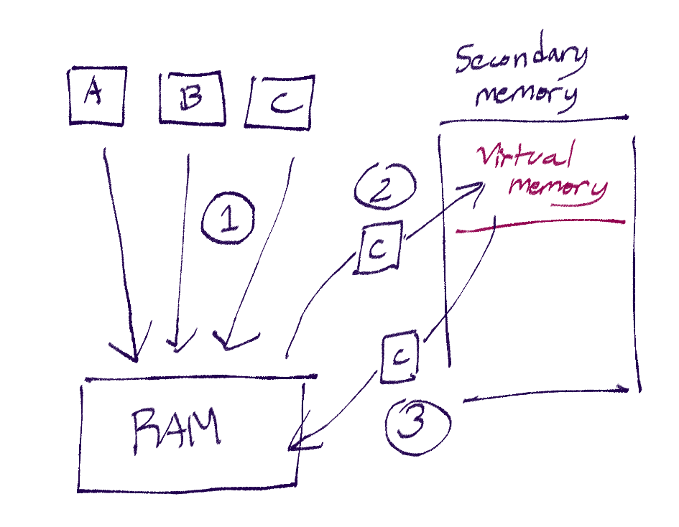 Virtual memory is a workaround made so that computers can manage to process the data and programs it needs to even if it surpasses what the RAM can hold.

1. Pages A, B, and C are sent to the RAM as they are currently being processed. A page is a unit of data used for processing data.
2. RAM only has enough space to hold two pages, and C isn’t immediately required, so page C’s data is stored in the virtual memory, which is a temporary partition of the hard drive acting as an extension of RAM
3. Once other pages have been processed to the point there is enough space, C is sent back to RAM to be used in processing.

Secondary memory

Secondary memory is where user files and programs are stored, including OS. All secondary memory is non-volatile, so data remains even after power is shut off. Secondary memory components are easy to replace.

Magnetic memory

Magnetic memory relies on the properties of magnetism to store data; uses plates called platters that are made out of magnetic material. As the plate is spun to be read or written, a writing or reading arm is placed across it. A writing arm uses electromagnets to magnetize small dots of the platter, the magnetic field of a part representing binary values. The location of data on a platter is separated into tracks. An example of magnetic memory is HDD (Hard Disc Drive).

[image here]

Advantages:

* Cheaper per unit of data
* Portable
* Large storage capacity
* High number of read/write cycles

Disadvantages:

* Vulnerable to wear and tear/fragile
* Noisy

Optical memory

Optical memory uses disks with very small holes called pits and the solid disk in between the holes called lands to represent 1 and 0 binary values. Pits and lands are organized in a spiral track that starts from the center of the disc, and as the disc spins, the data is placed further outwards. A laser from an optical disc reader is shone onto the disk where it’s being read; if the laser reflects, a sensor will register that as a 0. If the laser goes through a pit, no reflection will occur, and that will be registered as a 1. Examples of optical memory are blu-ray discs and CDs.

Advantages:

* Cheaper per unit of data
* Portable

Disadvantages:

* Vulnerable to wear and tear
* Data can be ruined from scratches
* Slow access times

Solid state memory

Solid state memory uses NAND and NOR technology to flash data onto chips, using transistors and floating gates to control the flow of electrons. The state of a transistor can represent binary 1s or 0s. Solid state memory is read and written sequentially, that is, in order.

Examples include USB flash drives, SSD (solid state drive), and SD cards.

[picture here]

Advantages:

* Durable
* Fast access times
* Portable
* Runs quietly
* Produces less heat than other storage devices
* Uses less power than other storage devices

Disadvantages:

* Expensive per unit of data
* Data can be corrupted as electrons can leak
* Limited read/write cycles

Cloud memory

Cloud memory is memory stored on servers hosted by a third-party, where a user can access and store their data on the server through the internet.

Advantages

The third-party will usually have advanced security measures in place such as encryption and multi-factor authentication so the data will be less prone to being hacked or lost. The third party also usually has multiple backup servers for extra security in the case a server shuts down.

One can also access cloud storage from any location or device as long as they have authentication and an internet connection.

One can also easily upgrade to a larger storage capacity by changing storage plans.

Disadvantages

Using cloud storage can be expensive since one must pay the third-party hosting the servers.

Anything on the internet is susceptible to hacking and viruses

If something happens on the third-party’s end like a power outage or fire, you can lose your data

If the client has a bad internet connection, accessing the data may be an issue.

Embedded systems

We have already discussed computer systems. Features that define a computer system is: (you don’t need to memorize this, just the embedded systems one)

* They are multifunctional. They can be used for calculations and data analysis, to web browsing and gaming.
* They are programmable. You can add programs or change programs on the computer easily.
* Hardware components can be easily replaced
* They depend on operating systems like Windows or Linux

Embedded systems are electronic systems that have other specific features that differentiate them from computer systems:

* They have a dedicated function – they were built for a specific purpose.
* Uses firmware – software that is hard-programmed into the circuits
* They cannot be reprogrammed
* They have dedicated hardware
* Usually built into the hardware
* Doesn’t require much power to run
* It can work automatically
* Small in size – fit easily into whatever tool they’re in
* Real-time operation

Examples of embedded systems include normal fridges, kettles, cars, microwaves, industrial robots, digital cameras, keyboards, and wifi routers. Embedded systems can also have CPUs, just so you know.

Benefits of embedded systems

1. They are small in size and thus can fit easily into almost any device
2. Relatively cheap to produce
3. Since they are usually dedicated to one task and have simple interfaces, they don’t need operating systems
4. Consume very little power
5. Can be controlled remotely
6. Very fast reaction to input since they operate in real time
7. Reliable as they are mass produced and designed to prioritize reliability

Drawbacks of embedded systems

1. Upgrading devices is difficult
2. Specialists are needed to troubleshoot such devices
3. Interface can be confusing even if it appears simple
4. Anything connected to the Internet is vulnerable to hacking and viruses
5. Wasteful as they are difficult to upgrade and are usually wholly replaced

General-purpose computers

General purpose computers are not embedded systems – these computers are designed to perform many different tasks and functions, and are programmable. Examples of general-purpose computers include laptops, desktops and smartphones.

Input and Output Devices

Input vs output

An input device is a device that allows data to be entered into the computer. An output device takes processed data from a computer and allows it to be heard, seen or otherwise understandable by humans.

For each of the examples of input and output devices we’re going to look at here, you should also remember a real-life example for them.

Output devices

LCD (Liquid Crystal Display) screen

Shines light through crystals to output an image

Example: calculators

LED (Light Emitting Diode) screen

LCD projector

Shines light through crystals and then through a lens to project an image

Example: used to project movies in cinema theaters

Actuator

A device that is operated by signal to produce physical movement.

Example: used in robotic arms used to build parts in a factory

Speaker

Example: used in a concert to play music for the audience

Inkjet printer

Squirts liquid ink from nozzles to output an image

Example: can be used in a house to print photographs

Laser printer

Uses a rotating drum and powdered toner to output a document

Example: can be used in an office to print letters.

3D printer

Builds layers of materials to output a 3D object

Example: used in medicine to create prosthetic limbs

DLP (Digital Light Processing) projector

Uses light from millions of small mirrors to output an image

Example: can be used in a classroom to project a presentation

Input devices – sensors

Sensors capture different types of data to be converted and processed by a computer, usually at set intervals of time. This list will list the different types of sensors and what the data they’re collecting is for some of them.

Magnetic field sensor

Senses the presence and/or strength of a magnetic field

Infra-red sensor

Detects and records infra-red radiation

Example: used in security systems to sense the presence of a person

Light sensor

Example: used in street lights so the lights will turn on when the surrounding light outside is low enough

Proximity sensor

Detects/measures how close an object is to the sensor using electromagnetic fields

Example: used in robots in manufacturing to move around the factory without bumping into things

Pressure sensor

Used to measure the pressure inflicted on the sensor – can be solid, liquid or gas

Example: used to measure the pressure of water in an aquarium, or in a security system to sense if an important item has been removed from its place

Humidity sensor

Measures the humidity in the air.

Example: used in digital weather stations to record the humidity of the air and report it

Moisture sensor

Used to measure the moisture of an object, not like humidity.

Example: used in art galleries to ensure a piece isn’t too moist and starts decomposing.

Temperature sensor

Example: used in a kettle to know when the water is boiling

Accelerometer

Used to measure the acceleration of an object

Example: used in car airbag systems to know when a car has crashed to release the airbag

Flow sensor

Measures the amount of fluid flowing through a certain environment

Example: used to measure the discharge of a river, used to measure the flow of pipes in a factory so they don’t rupture

Gas sensor

Measures the presence and concentration of a gas in the atmosphere around the sensor

Example: used in homes to measure carbon monoxide levels and ensure they are at a safe level

Acoustic sensor

Measures the level of sound around the sensor

Example: used in security systems to detect any sounds that could signify a break-in

Level sensor

Measures if a substance, such as a liquid, is at a certain amount.

Example: used to measure the water levels of a river to see if it will flood

pH sensor

Example: used to measure the pH of the soil of a field to ensure it is healthy enough for crops

Input devices – others

Barcode scanner

Scans a barcode to obtain data stored in the barcode.

Example: Used to scan and identify items in a grocery store register to get its price.

Digital camera

Captures light through its lens, converts them into binary data.

Example: Built into mobile phones to take photographs.

Keyboard

Allows user to press on keys that have corresponding ASCII code to each of them

Example: Keyboards are connected to PCs to input characters into a text document

Optical mouse

Captures light shone from the mouse that reflects back to it to track the mouse’s movements.

Example: Mouse connected to PC to click and interact with elements on a web page

QR code scanner

Uses a sensor to capture light reflected from a QR code and converts it into binary

Example: Used to easily get the menu of a restaurant by scanning a QR code with a phone

Scanner (2D and 3D)

Uses sensors to capture light reflected from an object and converts it into binary

Example: Used to photocopy a test paper to print again

Touch screen

Uses pressure, conductivity or light to register the touch of a user’s hand and calculates the coordinates of the touch

Example: Used in tablet screens to easily navigate apps

Network Hardware

NIC (Network Interface Controller)

What is it that allows all our devices to be connected on one network and communicate with each other? It is a component called the NIC, connected to or built into computers’ motherboards to allow them to connect to a network. It uses a protocol to ensure successful communication. The NIC is what contains the MAC address of a device, which is why the MAC address is set by the manufacturer of the NIC/computer.

The NIC can be connected to a network either wirelessly or wired, which uses an ethernet cable.

Addresses used in networks

MAC address (Media Access Control)

MAC addresses are specifically the physical address of a device on the network. ‘Physical’ makes sense since it is built into the NIC.

We have already gone over MAC addresses before, but it is important to remember all these aspects of them.

Example:

A1 : B2 : 7F : FE : EE : 80

* It has 48 bits
* Represented as 6 pairs of hex numbers
* Separated by colons
* It is static / cannot be changed
* It is set by the manufacturer
* It is unique for every device

IP addresses: general

Standing for Internet Protocol address, IP addresses are used as a global address on the Internet. – for example, in order to send a data packet to a device on the Internet, you’ll need the IP address as the destination.

Functional aspects include:

* Can be either static or dynamic
* It is set by the internet service provider
* Not necessarily unique for every device (will be explained later)

However, there are two types of IP address we need to know about. They only differ in number of bits and the way they’re represented though, they both function the same.

IPv4 address

Example:

172.254.99.101

* 32 bits (4 bytes)
* Represented in denary
* Each byte separated by a dot
* Has a limited range of addresses to use

IPv6 address

Example:

A456 : 1234 : DB4B : BCE9 : 09F1 : 1234 : 1AAA : AF45

* 128 bits (16 bytes)
* Represented in 8 groups of 4 hex values
* Separated by colon
* Has a bigger range of addresses to use than IPv4

Dynamic vs static addresses

Static addresses are addresses that cannot change, and dynamic ones are those that can. There are advantages and downsides to each:

Static:

* A static address reduces privacy and security as you can be fully tracked using the address
* Allow for faster upload and download speeds
* More expensive to maintain as the device has to be running all the time

Dynamic:

* Provides more security as your address is different every time
* Can cause problems when using systems such as VoIP (Voice Over IP) since this type of addressing is less reliable, causing disconnects which lead to changing the IP address, causing the VoIP to fail.

Routers

Function of a router

A router is used to send data to a specific location on the network it’s connected to, another device, directing data packets from one router to another to reach its destination. It assigns IP addresses to devices connected to its LAN, and allows LANs to connect to the Internet/WAN.

A router will ‘face’ two ways – private and public. It will form an LAN network with all the devices directly connected with it, assigning each device a local IP address. On its public face, it will have its own IP address, given to it by its Internet service provider. Using this IP address, it can communicate with other routers on the Internet/WAN and thus connect its LAN to the Internet.

LAN (Local Area Network)

An LAN is a computer network that connects devices within a limited area, such as a house. Devices within them will have their own unique IP within the network, but not necessarily unique compared to devices on other LANs (This is the ‘not necessarily unique’ thing mentioned earlier). Devices in an LAN don’t necessarily need to use IP addresses to communicate, either. They can communicate using only their MAC addresses identifying them.

WAN (Wide Area Network)

A WAN on the other hand covers a vast area. The Internet is a WAN. In order to communicate, devices need IP addresses. It is meant to connect LANs into one big network.

Software

Software is a set of programs that control the computer. They are only pieces of data in the computer, and do not exist physically, but they are practically the main way modern computers do all their functions.

Software types

There are the general types of software;

Firmware

Firmware is software embedded into the hardware of a computer, and is required for a computer to boot and run. Includes the BIOS (Basic Input-Output System) and bootstrap programs. It can be considered the lowest level of computer software. Firmware is found in the ROM of a computer.

System software

System software manages the hardware and processes of the computer. Includes OS and utility software. This runs on top of firmware.

Application software

Software that provides services for the user. They can easily be installed and uninstalled, and are used for a variety of purposes. Includes all kinds of programs, including word processors, video editing software, web browsers, video games, and email clients.

System software

There are two types of system software we should know about:

OS (Operating System)

I made a whole presentation about the OS, so I will just write the main points here. It is likely you will be asked to write short points like this anyways. Make sure to check the presentation for an in-depth explanation.

The OS is software designed to manage the hardware, programs, and memory of a computer.

The OS has many functions and tasks:

* It provides a platform for applications to run on
* Manages memory
* Manages files
* Handles interrupts
* Manages peripherals
* Manages drivers
* Provides a user interface (UI)
* Manages user accounts
* Providing system security

Examples include Windows, Linux, MacOS, iOS, Android

Utility software

Utility software works to maintain the computer, keeping it running efficiently, keeping it safe, and providing useful tools for the user. These often come with an OS. Examples include:

* Defragmentation software
* System clean-up
* Antivirus
* Security
* Screensavers
* Disc analysis and repair

Interrupts

Interrupts are special signals used to tell the computer something needs its attention. Thus, they are prioritized over other processes.

Interrupts are generally used for things that must be immediately responded to and are time-sensitive. For example, when a USB drive is plugged in and data is being copied into the computer, an interrupt is needed to tell the computer to immediately store the incoming data before it is overwritten.

Interrupt handling

This of course, is the job of the OS. This is how it will work:

1. An interrupt is sent to the CPU. The interrupt is stored in a queue of interrupts.
2. After every FDE cycle, the queue is checked, and the most important interrupts are handled first. A low priority interrupt may be ignored, while a high priority interrupt will be handled immediately.
3. The CPU stores the data of the program it was originally processing before handling the interrupt.
4. Every interrupt signal has an ISR (Interrupt Service Routine) associated with it, which is executed by the CPU. Think of it as a small program.
5. The CPU checks the queue and processes any other high priority interrupts.
6. The data of the original program is fetched and FDE cycles are continued.

Software interrupts

Examples of software interrupts include division by zero and two processes trying to access the same location in memory at once.

Hardware interrupts

Examples of hardware interrupts include moving a mouse and pressing a key on the keyboard.

Programming languages

Programming languages are used by programmers as instructions for a computer to follow. There are 2 classifications for programming languages.

Language types

There is low-level and high-level language. Low-level language is closest to machine language, and is very specific, and requires high knowledge of the computer’s hardware and memory.

Because of this, it can manipulate hardware directly, and runs more efficiently. However, it is more difficult to debug, and is hardware-dependent and not portable.

High-level language is closer to human language. It is more logic focused, and uses methods that can run multiple low-level instructions in one line of code. Because of this, it is easier to debug and less prone to error. High-level language is also portable, which means it can run on any computer regardless of hardware.

However, it has less control over manipulating memory, and runs less efficiently than low-level languages. Furthermore, it must be translated into machine code before running.

There are types of languages that fall under these categories.

Machine code

This is a type of low-level language. Machine code is the lowest level of language, that is executed by the computer. It is in the form of binary.

Any code must be converted into machine code before it is able to be understood and executed by the computer.

Assembly language

Of course, binary is extremely hard to work with, so for low-level language, assembly language is more commonly used. Assembly language uses mnemonics such as STO (store) and ADD to represent code. Assembly language is close enough to machine code that high-level languages are usually translated into it before being translated into machine code.

Examples of high-level languages

High level languages include languages such as Python, C#, C++, JavaScript, and Java.

Translators

Translators are used to convert other programming languages into machine code. This section will be talking about types of translators.

Assembler

An assembler is used to convert assembly language into machine code. That’s it. Assembly language will have faster translation than high-level languages.

Compiler

A compiler is used to translate high-level language into machine code by translating all the code of a program at once, and returning it as an exe (executable) file. Before compiling all the code, it checks it for errors, and produces an error report if any are found.

This way, the exe file can easily be distributed to different computers to run the program. It also executes fast since all the code will already be in machine code.

However, the code cannot be edited once in exe form, so it must be edited and recompiled.

Another thing is how compilers detect errors – because it will check all the code for syntax errors before compiling it, and not run when errors are found.

Interpreter

An interpreter is also used to translate high-level language, but in a different way. Interpreters check, translate and run code it line-by-line – on the go, so to say. It checks each line before translation for errors, and stops running the program if an error is found, until it is fixed.

This makes it easier to do iterative testing and debugging, because you can easily edit code without having to recompile.

However, it executes slower than compilers because it must translate and run each line individually. Using it also requires any computer running the program to have an interpreter and the source code.

Errors are returned in real time, as it reads each line of code to check if it is correct before execution.

IDEs (Integrated Development Environment)

An IDE is a kind of software that is used for writing programs using a code editor (sort of like a word editor) and provides an interpreter(for whichever language you are using) a run-time environment, and error diagnostics.

Editor

The code editor is where you type in the code. It can have features such as:

* Auto-completion

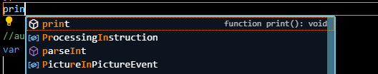

You can start typing a word and it will suggest frequently used options

* Auto-correction
* Prettyprint

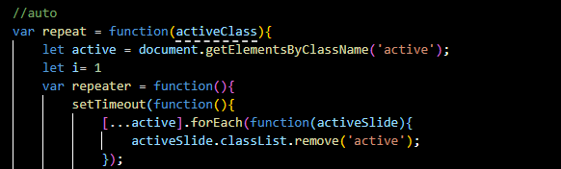Changes the color of identifiers and text to make it easier to read; in this example, variable names are made light yellow.

* Block minimizing

You can minimize sections of code to make it easier to read (like minimizing windows)

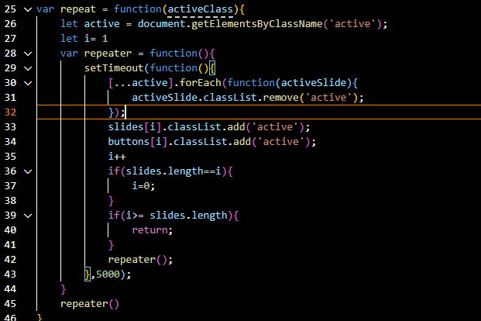

Before minimizing

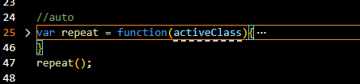

After minimizing

Run-time environment

A run-time environment provides everything needed to run a program, providing space for inputs and outputs.

Debugging tools

During development, tools such as this help a lot for tracking what is going on in the program, to fix any bugs.

* Break points

Allows the user to set points in the code where it will stop running and pause.

* Variable watch window

Allows the user to see variable values in real time.

* Stepping

Allows the user to run lines on demand, one line at a time.

Automated Systems & More

Automated systems

An automated system is a combination of hardware and software designed to function without human control. They are made up of 3 main components:

* Sensor

We discussed sensors before, in hardware. The same knowledge of them can be applied here. Their purpose is to collect information from the surrounding environment and send it as data to the microprocessor.

* Microprocessor

Remember, a microprocessor is an IC (integrated circuit) with all the components of a CPU. Here, it is used to process the data from the sensors and produce an output, which is sent to the actuator.

* Actuator  
  An actuator receives instructions from the microprocessor and outputs it by executing actions, usually in physical form.

Scenarios

I cover 3 scenarios – gaming, lighting and science – in my PowerPoint presentation. They have multiple of these kinds of scenarios listed in the syllabus, but I don’t believe we need to memorize any of them.

Advantages and disadvantages

Use these points as long as they apply to the scenario you’re talking about.

Advantages

* Less people need to be hired / cheaper in the long run
* More accurate and less prone to human error
* Consistent and reliable
* Can work 24/7/continuously
* Can work in dangerous environments/dangerous materials
* Faster than humans

Disadvantages

* Replaces human jobs
* Expensive initial cost
* Requires expensive and specialized maintenance
* Requires extensive testing
* Inflexible when it comes to new situations
* Any automated system is susceptible to cyber attacks

Describing how an automated system works: IGCSE style

There will usually be a question asking you to describe how a given example of an automated system works. It will go something around ‘an automated system uses this sensor and a microprocessor to do this when this condition is met. Describe how the sensor and microprocessor work together to do this.’

Steps in writing the answer:

1. The sensor will continuously record data/information (according to what kind of sensor, if not given you may have to think of a suitable sensor to use in the scenario)
2. The data from the sensor is sent to an ADC (analog to digital converter) and the data is converted to digital values
3. The data is then sent to and processed by the microprocessor
4. Data is stored in system
5. The microprocessor compares the data to stored values, if they match, then microprocessor sends signal to [something depending on the scenario, could be an actuator, sending a warning message, etc.]
6. Otherwise [if given in scenario, microprocessor can do something else, or, nothing could happen]
7. This process is repeated continuously until the system is turned off

Robots and robotics

I am also sincerely sorry to anyone else studying this chapter right now, a lot of terms are going to sound similar in definition to each other.

Robots

Robots are machines designed to do tasks similarly to how a human would, specifically physical work or actions. The main needed characteristics of a machine to be a robot are:

* A mechanical structure
* Electrical components
* Programmable
* It can move

Robotics

Robotics is a branch of computer science that studies the design, construction and operation of robots. Just remember those key words, it’s straight out of the mark scheme.

Examples of robots

* Domestic robots

According to Wikipedia, a domestic robot is a type of service robot that is primarily used for household chores.

* Drones
* Factory equipment

Robots are used widely in factories for labor work like capping bottles, labelling cans, filling molds, drilling down steel, and all sorts of other things, usually specific to what the factory is manufacturing.

Fields where robots can be used

* Entertainment
* Industry
* Transport
* Medicine
* Domestic
* Agriculture

Advantages and disadvantages of using robots

Yeah, just take it all from the list of points I made for automated systems. Just to clarify, I won’t say that robots are an automated system, because I’m not sure if that statement is correct or not in IGCSE Computer Science, and I don’t think they ever mention it. Sorry.

AI (Artificial Intelligence)

Although it ‘artificial intelligence’ does sound like it is a kind of machine, it is actually more general than that. AI is a branch of computer science dealing with simulating intelligent behavior in computers.

Characteristics of AI systems

* Collects data
* Stores rules on how to use the data
* Has the ability to reason
* Has the ability to learn and adapt
* Uses machine learning
* … and characteristics related to machine learning (we’ll see below)

Expert systems

An expert system is a machine system designed to mimic human experience and the decision-making abilities of an expert, usually to answer questions in a certain topic or field. An example could be a doctor expert system that diagnoses a patient based off their symptoms. An expert system comprises of 4 parts:

* Knowledge base

A database of facts on the topic.

* Rule base

A set of rules or logic for the expert system to follow when operating. We usually say rules rather than programming code when it comes to this, because they are usually presented as simple ‘if-then-else’ statements.

* Inference engine

A program that applies the rules to the knowledge base to make decisions.

* UI (User Interface)

Allows users to interact with the system. This includes letting them input, as well as showing the user the output.

Machine learning

Machine learning is a form of AI when a program has the ability to automatically adapt and change its own rules and data. This is done by training the program.

There are two different training methods:

* Supervised

In supervised training, a human provides the desired input and output, and the program adapts itself to it.

* Unsupervised

In unsupervised training, the program is only given input and must work out the output itself.

In any training method, the program adapts itself based off patterns it finds in the data, and stores its successful and unsuccessful outputs, so it knows what is most likely to work next time.

Example of a question



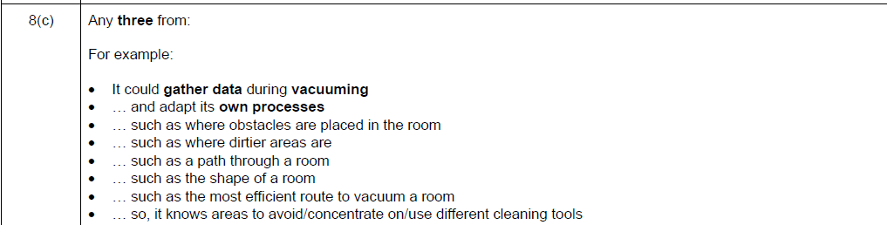

1. A register is a computer component that stores data.
2. It would be difficult to discern and split places when the characters have no space between them (1 and 12 would only show up as 112) , so resorting to alphabetical characters keeps each value to one place.
3. Do you get it. Do you get the reference
4. Because ½ is 0.5, so it’s 0 with a remainder of 0.5.
5. Electric currents can make an electromagnet from the wire. Crosstalk gets worse the longer the wire is.
6. For example, it can turn a bit from 0 to 1.
7. It’s 9pm and I’m tired and I’m sorry I can’t think of anything better
8. To get into the nitty gritty, a digital certificate links the public key and website together to prove that it is secure. The certificates are given out by *certificate authorities* that issue them.
9. This short research paper gave me a better idea of how these worked <https://img.faculty.unlv.edu/lab/wp-content/uploads/2021/01/Double-entry-and-read-aloud-identify-more-errors-than-visual-checking-Heather-Jenya-Spencer-27-poster-7-Kim-May-9-2011-CONTENT-AND-FORMATTING-DONE.pdf>
10. Fun fact – computer clocks (Real Time Clock) are actually crystal oscillators that use the frequency produced by crystals like quartz and convert the waves into digital signals that can be used in the computer.
11. <https://thegeeksclan.com/von-neumann-architecture/#Fetch-Decode-Execute_cycle> a good, in-depth explanation